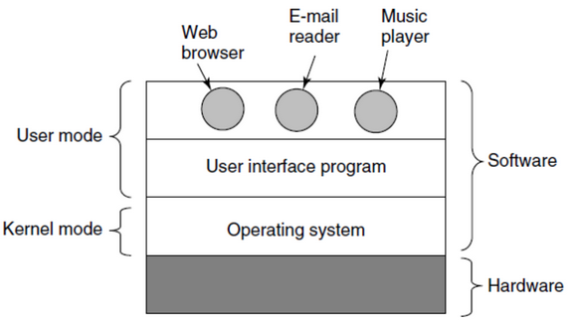Operating systems were created to act as a layer between end user applications and the hardware

The architecture (instruction set, memory organization, I/O, and bus structure) of most computers at the machine-language level is primitive and awkward to program

Operating systems turn “ugly” hardware into “beautiful” abstractions

# CPU (Central Processing Unit)

Has a specific instruction set

Fetches instructions from memory and executes them

Uses registers for storing temporary values and control information

Normally have two modes of execution:

* Kernel

allows all instructions and hardware features usage

* User

allows only a subset of instructions and features

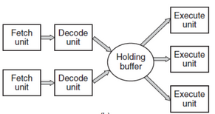Modern CPUs use a pipeline in order to increase performance; whilst executing an instruction, the next can already be decoded and the following one be fetched

Superscalar CPUs have many units of the same type   
  
  
  
  
CPU performance has improved with techniques like

* Multithreading

allows different tasks to take place in a CPU, which can switch between them if, for instance, one is waiting for a value from memory

* Multicore

CPUs can have several cores, effectively being composed of several processors

* Specialized processors

GPUs, for example, are very good with many small computations in parallel

# Memory

Not just one entity

• Consists of a hierarchy of layers (mostly due to cost)

• The top layers have higher speed, smaller capacity, and greater cost per bit than the lower ones

• Commonly accessed information is, when possible, stored in faster memory via a process known as caching

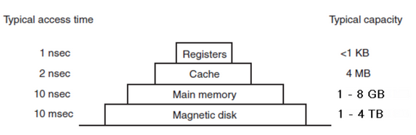There are levels of cache; level 1 tends to be in the CPU. A higher level of cache is larger but slower.

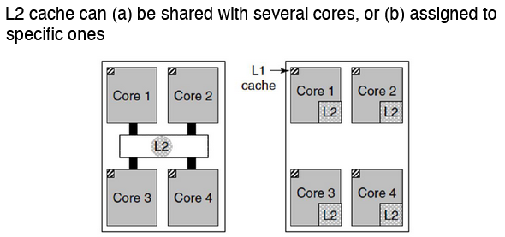  
  
  
  
  
  
  
  
  
  
  
  
  
Caching system issues:

* When to put a new item into the cache
* Which cache line to put the new item in.
* Which item to remove from the cache when a slot is needed.
* Where to put a newly evicted item in the larger memory.

Main memory (Random Access Memory – RAM) is the next level; larger but slower

Read Only Memory (ROM) (non-volatile)

EEPROM (Electrically Erasable Programmable ROM) also exists in some cases and is non-volatile too, but

allows updating

CMOS (Complementary Metal-Oxide Semiconductor) (volatile) is a type of memory that is commonly used to store the current time and date, and is powered by a small battery – It can also contain some configuration parameters for the machine

Flash memory is intermediate in speed between RAM and disk

• It is commonly used in portable devices

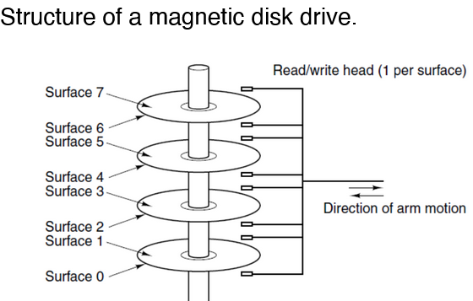• Write operations wear it out

Magnetic disks (Hard Disk Drives – HDDs) are considerably

cheaper and have more capacity than RAM, however,

they are also much slower

Solid State Drives (SSDs) also store large quantities of non-volatile data and have better performance, although they are more expensive. SSDs have no moving parts and use flash memory for storage

Hybrid drives combine SSDs and HDDs, with the former acting as cache, resulting in high speed access to data without compromising capacity

Sometimes there is not enough memory to hold a program. Virtual memory uses disk space to temporarily

store information that does not fit in the existing memory.

# I/O (Input/Output)

An I/O device usually consists of a controller and the device

The controller is a hardware component that accepts commands from the operating system, e.g., SATA disk controller. Each controller is different, so to minimize operating system complexity, a special type of

software is used; device drivers. Vendors of devices (e.g. web cam) create device drivers for each operating system they support.

Input/Output can take place in several ways; the simplest form is called busy waiting:

1. A program issues a system call

2. The operating system translates it to a call to the device driver

3. The driver initiates the I/O and continuously polls the device to check if it has completed the operation

4. Once that is the case, it returns any result and the operating system passes it to the original caller

Main disadvantage; The CPU is tied up during the polling process

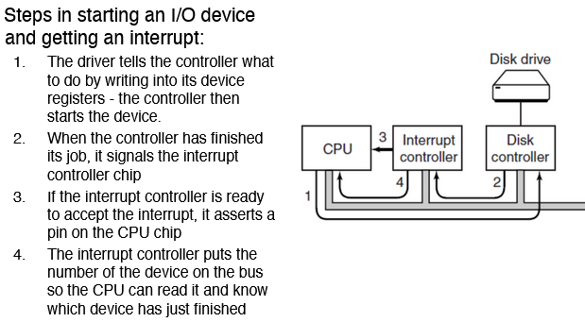An alternative way to do I/O is for the device driver to initiate the request to the device and ask it to be notified when it finishes the operation. Whilst the device is completing the operation, the operating system can block the original caller and do other work. When the controller detects the end of the original operation, it generates an interrupt to signal this.

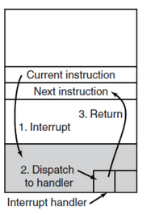

Interrupt processing involves taking the interrupt, running the interrupt handler, and returning to the user program.

Another way for doing I/O further minimizes CPU intervention: Direct Memory Access (DMA)

• This is a chip that can get instructions from the CPU, namely the number of bytes to transfer, the direction and the memory addresses involved

• When the DMA chip completes the operation it will generate an interrupt

# Processes

Abstraction of programs in execution

Process is associated with an address space and a set of resources

Process can be thought of as a container – holds all information needed to run program & manage it

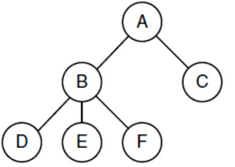A process tree. Process A created two child

processes, B and C. Process B created three

child processes, D, E, and F.

Mounting in UNIX

(a) Before mounting, the files on the CD-ROM are not accessible.

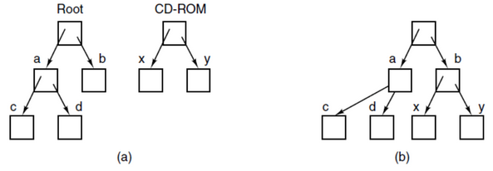(b) After mounting, they are part of the file hierarchy.

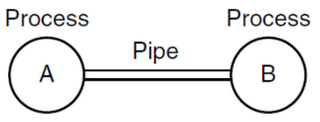  
  
  
  
  
  
  
  
  
Processes can be connected via a pipe

The information specific OSes keep about processes varies, but a set of data is very common:

* Process ID
* Process name
* User running the program
* Executable file associated with the process
* Current values of the registers, variables and program counter

In multiprogramming systems, CPUs quickly switch from process to process. This gives the illusion of parallelism (pseudo-parallelism), even with just with one CPU.

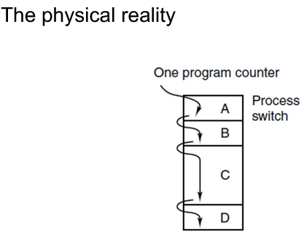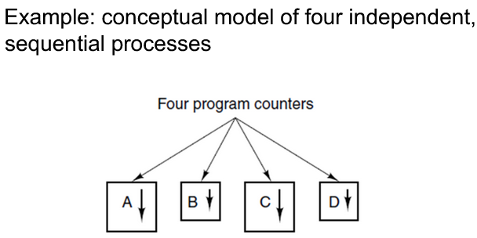

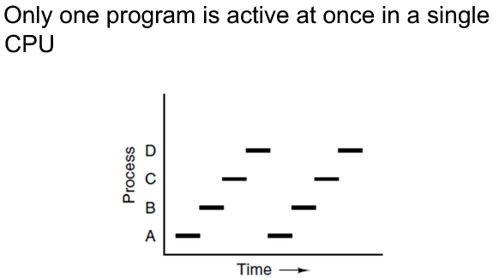

Main events that cause processes to be created:

* System initialization
* Execution of a process creation system call by a running process
* A user request to create a new process
* Initiation of a batch job

In POSIX OSes (UNIX, Linux, OS X, etc), a new process is created via one system call: fork

* A clone of the calling process is created
* Parent and child processes use an identical copy of the memory image, the same environment values and the same open resources
* However, the address space is separate

fork() not only creates a new process, it is special in that it returns twice

* In the parent process, it returns the child process id;
* In the child process, it returns zero

The code base is the same for both processes, starting from the fork(). The child process can afterwards change the memory image and run a new program

Process termination occurs typically;

* Normal exit (voluntary)
* Error exit (voluntary)
* Fatal error (involuntary)
* Killed by another process (involuntary)

Some processes interact directly with users, independently of how they are started, e.g., file explorer

Others work in the background and react to particular occurrences (not independent to startup); these are called daemons, e.g., process that checks for OS updates

Three states a process may be in;

Running - actually using the CPU at that instant

Ready - runnable; temporarily stopped to let another process run

Blocked - unable to run until some external event happens

The lowest layer, scheduler, of a process-structured OS handles interrupts and scheduling. Above that layer are sequential processes

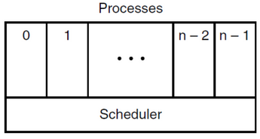

## Threads

having parallelism whilst sharing address space can also be beneficial; a thread is a component of a process

Creating a process carries an overhead which is significantly higher than for creating a thread

Context switching between threads is also faster

Sharing address space makes it easier to write code that deals with several activities that can block at certain points but need to interact

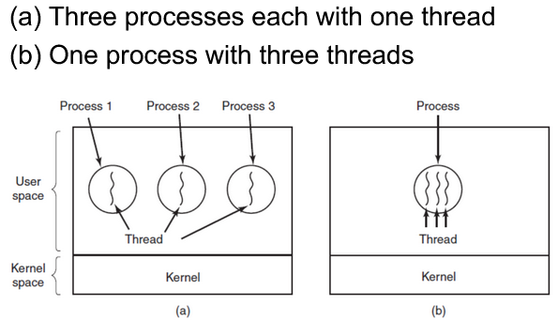The classical thread model:

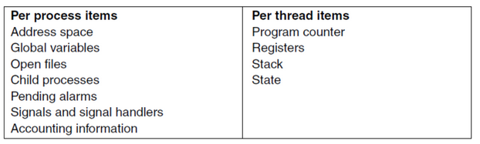  
  
  
  
  
  
  
  
  
  
Threads have their own stacks and follow the same states as processes

Whan a process is started, it always has a single thread. This thread can create a new one by calling a

library function, and specifying which procedure the new thread should run. The calling thread usually receives an identifier for the new thread

Threads can terminate normally via a library call; scenarios are analogous to process termination.

Some systems allow threads to wait for others to finish, in a “join” operation

For the sake of portability, a standard API was created for thread management

This defines a package called Pthreads which specifies many functions

This API is implemented by most POSIX OSes

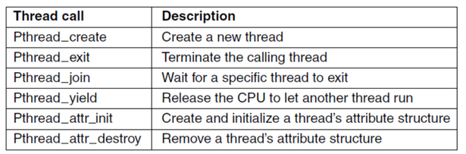

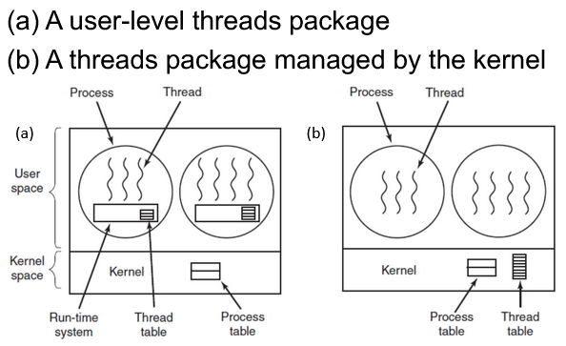  
  
  
  
  
  
  
  
Thread Implementations:

With a user-level implementation of threads, the kernel is not aware of them

Advantages:

– Can be implemented on OSes with no thread support

– Context switching is fairly simple and fast as this is done with local calls only

– Scheduling algorithms can be customized to processes

Disadvantages:  
– Blocking system calls affect all the threads in the process

– Relies on threads voluntarily giving up the CPU

– Many reasons for using threads are based on taking advantage of blocking calls

With kernel-level threads, the kernel keeps a list of threads just as it keeps a list of processes

Advantages:

– Blocking system calls can be used transparently

– New non-blocking system calls are not required

– Page faults caused by one thread do not affect others

Disadvantages:

– System calls are costly

– Multithreaded process fork semantics

– Signal handling – which thread takes a signal?

Hybrid implementation

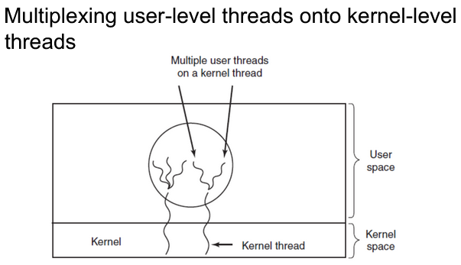

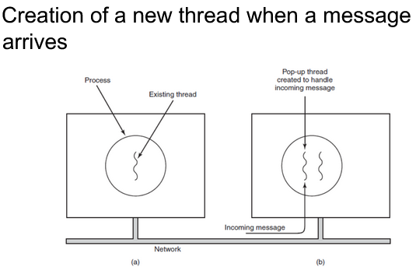  
  
  
  
  
  
  
  
  
  
  
  
  
  
  
Pop-up threads

Making Single-Threaded Code Multithreaded

Issue: Conflicts between threads over the use of a global variable

Solution: Threads can have private global variables

Other issues exist, including:

– Non re-entrant library procedures

– What happens if a thread loses the CPU during a memory allocation process?

– How to address signals?

## Interprocess Communication (IPC)

Processes need to be able to communicate to:

* Pass information which is relevant for a given multi-process task
* Prevent trying to access exclusive resources simultaneously
* Work with an appropriate sequencing of events when there are dependencies

Threads share memory, hence they can communicate that way, but they also need to:

* Prevent trying to access exclusive resources simultaneously
* Work with an appropriate sequencing of events when there are dependencies

Race Conditions

Even processes can share common storage; this creates the potential for issues when they change something in that storage

A race condition is said to take place when two or more processes are reading or writing some shared data; and the final result depends on who runs precisely when.

Parallelism has many benefits, but it further increases the chance of race conditions; debugging parallel programs can be challenging

#### Mutual Exclusion

Mutual exclusion is a technique commonly used to avoid race conditions; if a process is using a shared resource, other processes are excluded from doing the same

One way to achieve this is by identifying the parts of the program, critical regions, where processes access shared resources and making sure that two or more processes are not in their critical regions at the same time.

A “good” solution to race conditions should satisfy the following requirements:

1. No two processes may be simultaneously inside their critical regions.

2. No assumptions may be made about speeds or the number of CPUs.

3. No process running outside its critical region may block other processes.

4. No process should have to wait forever to enter its critical region.

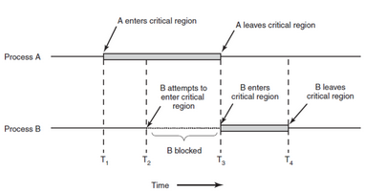

Proposals/Solutions:

* IPC with busy waiting
  + software solutions
  + hardware solutions
* IPC without busy waiting
  + IPC with semaphores
  + IPC with monitors
  + other techniques

##### IPC with Busy Waiting

Various proposals exist for achieving mutual exclusion using busy waiting

While one process is working on shared memory in its critical region, other processes will not enter their

critical regions and cause troubles. These processes will repeatedly check a certain condition, e.g., the value of a variable, to determine whether they can enter their critical regions

###### Lock variables

Create a variable (lock) initially set to 0. Before a process enters its critical region it inspects the lock. If 0 it changes it to 1 and enters the critical region. If already 1 it waits until the variable has value 0.

Problem:

– Process A reads the lock as 0

– Process B is scheduled before A can set the lock to 1

– Process B reads the lock as 0

– Both processes proceed to their critical regions!

Strict alternation;

If the execution assumes alternation of processes, a “turn” variable can be used

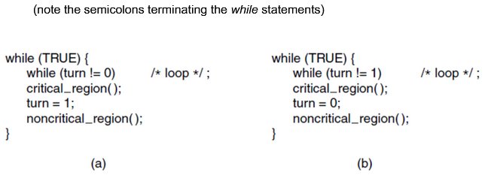

Is applicable when the wait is short

• If a process is much slower than the other one, the second will be blocked for a long (relative) time

• Does not comply with the critical regions rule “No process running outside its critical region may block other processes.”

###### Peterson’s solutions

* Works for two processes P0 and P1
* Critical region control:

enter_region(process);

critical_region();

leave_region(process);

Before entering the critical region, each process calls enter_region with its own id number, 0 or 1, and

waits, if need be, until it is safe to enter. After leaving the region, it calls leave_region to notify it is done.

Idea behind the solution is that before entering a critical region, a process indicates its interest but offers the opportunity to another one first.

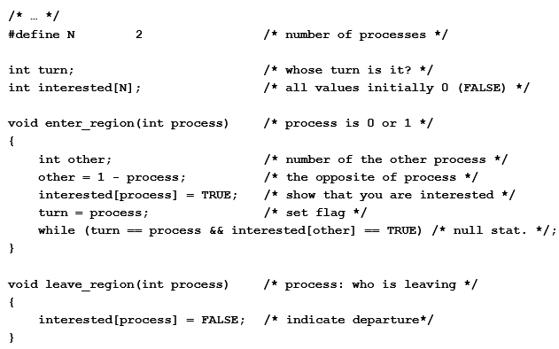

‘turn’ is actually used to offer turn to another process!

Note that if P1 crashes inside the critical region, P0 cannot enter. This cannot possibly be avoided.

– We want to make sure that a process crashing outside the critical region does not prevent others from entering like in the strict alternation algorithm.

Proof by contradiction:

P0 and P1 are in the critical region at the same time. How?

P1 entered enter_region first

P0 tries to enter & sets turn to 0

P1 sets turn to 1

P1 enters the critical region

P0 tries to enter the critical region! – not true;

P0 sets its interest before setting turn so P1 should have been in the loop, waiting.

###### Hardware Solutions

Disabling Interrupts

Disabling interrupts when entering a critical region

– Simple solution

– Requires a lot of power given to a process

– If there is a bug in the process it may never enable interrupts

– Does not work for multiprocessor systems

The TSL Instruction

CPU designers can provide CPU instructions that do several actions at a time

– each CPU instruction is atomic and no interrupt can occur while the instruction is running

Test and Set Lock (TSL) instruction allows us to construct a safe version of a lock

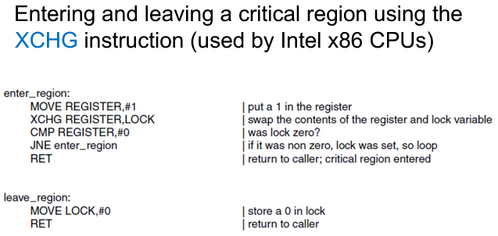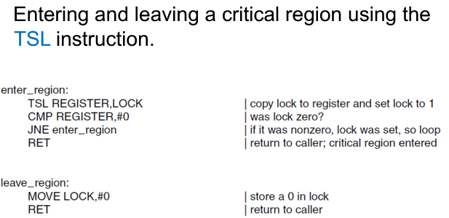  
  
  
  
  
  
  
  
  
  
  
  
  
  
  
  
  
  
  
  
  
  
  
  
  
Solutions involving hardware routines are simple and very easy to verify

Work for any number of processes at no extra cost

However, this solution still involves busy waiting

Problems with Busy Waiting:

• CPU time is wasted on checks

• Busy waiting can lead to priority inversion problem;

– consider two processes, H with high priority and L with low priority

– L is in the critical region

– H is waiting to enter the critical region

– H will waste CPU time checking whether it can enter the critical region and will not let L to do the work and vacate the critical region

– if priority of H is so high that L cannot run at all while H is running, this creates a deadlock; H will never enter the critical region

##### IPC without Busy Waiting

While one process is updating shared memory in its critical region, no other process will enter its critical region as it will be blocked.

###### Sleep and Wakeup

* sleep suspends/blocks the current process
* wakeup takes one process id as parameter, namely the process to be awakened

A sleeping process does not waste CPU time

The Producer-Consumer Problem

Two processes communicate through a common fixed-size buffer. One puts information in and the other reads it and takes it out.

What happens if the producer has a new item to add to the buffer but this is already full?

– One possibility would be for it to enter busy waiting, but that is what we are trying to avoid

– The solution is for it to go to sleep and be awakened when there is space in the buffer

What happens if the consumer is looking for new items but the buffer is already empty?

– Again, it could enter a busy wait, but we do not want that here too

– The solution is for it to go to sleep until a new item is available and it is awakened

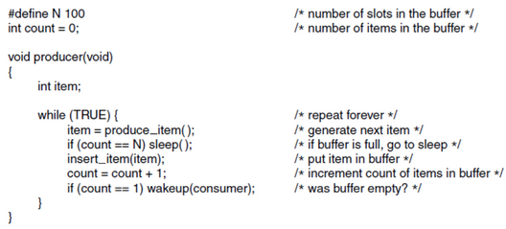

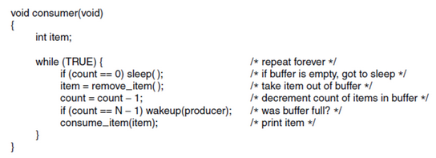  
  
  
  
  
  
  
  
  
  
  
  
  
  
  
  
  
  
  
  
  
  
  
  
  
  
  
This solution does not take into account the following sequence of events:

– the consumer reads the count variable as 0;

– the scheduler switches the running process to the producer

– the producer places an item in the buffer and, since count is now 1, tries to wake up the consumer

– The consumer is not asleep, it is simply in ready state until the scheduler puts it into running state, so the wakeup signal is lost

– when it is time for the consumer to run again, it will test the value it had read for count, and since it was 0 it goes to sleep

– once the producer fills up the buffer, it goes to sleep too

– both producer and consumer are asleep and none will issue a wakeup call

Solution (Dijkstra, 1965): Keep information about the number of wakeup calls which were not yet taken into account

Semaphores

a special variable type

– record number of wakeup calls

– allows two main operations: down and up

Down

* if the number of wakeup calls is 0, puts the calling process to sleep before completing the operation
* otherwise it decrements the number and allows the process to proceed

Up

* increments the number of wakeup calls
* if there were processes sleeping due to the down operation, one will be woken up and allowed to

complete down

The up and down operations work without themselves creating race conditions:

– Checking the value of the semaphore, and deciding if a process needs to enter the sleep state is an atomic operation

– Once a semaphore operation starts, no other process can access it until the operation completed or blocked a process as a result of the original call

Normally up and down are implemented as system calls where:

– the operating system briefly disables interrupts

– in a multiple CPU scenario, it is necessary to protect the semaphores with lock variables using TSL or

XCHG

This means there will be some busy waiting, but very limited as it is only for the very short semaphore calls, rather than the whole critical region

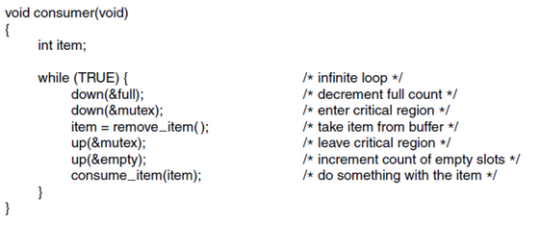  
  
  
  
  
  
  
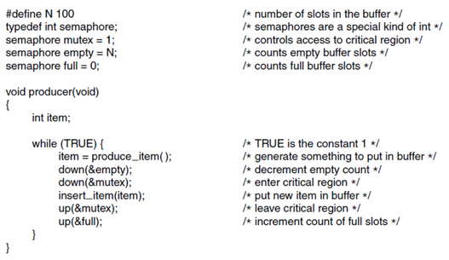  
  
  
  
  
  
  
  
  
  
  
  
  
  
  
  
  
  
  
  
  
  
  
  
  
  
Semaphores can be used for various purposes, including:

– Mutual exclusion – to protect a critical region whilst preventing a race condition

(e.g. mutex in the example)

– Synchronization – to prevent or force a certain sequence of events

(e.g. full and empty in the example)

Binary semaphores only has two values (0 and 1) and is used for mutual exclusion

Mutexes

A mutex is a simplified semaphore that ensures mutual exclusion;

• Only two states exist: locked and unlocked

• The simplicity results in efficiency advantage & it can be implemented in user space (provided a TSL or

XCHG instruction is available)

Requesting access to a critical region involves calling mutex_lock

– Works as the down operation in regular semaphores

When exiting the critical region a thread calls mutex_unlock

– As with the up operation in regular semaphores; will release currently blocked processes, but no count is kept

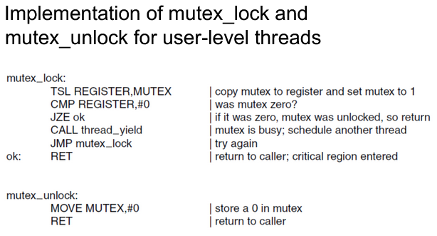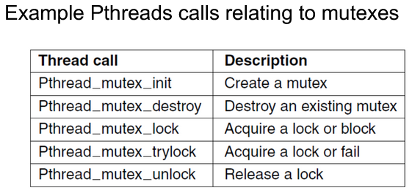

Condition variables  
Condition variables in Pthreads allow blocking threads based on some condition. This allows for more advanced scenarios than just using mutexes.

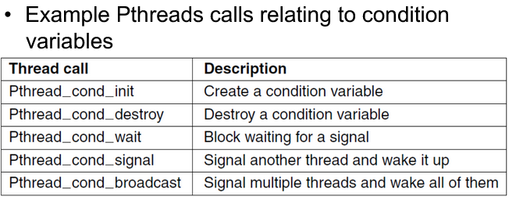

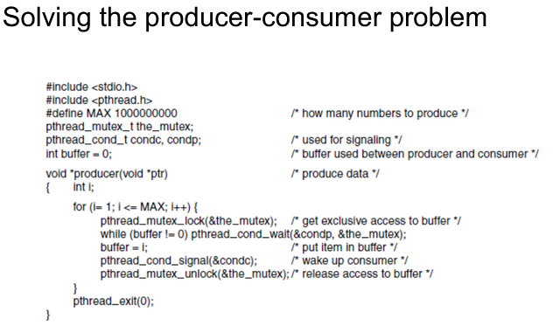

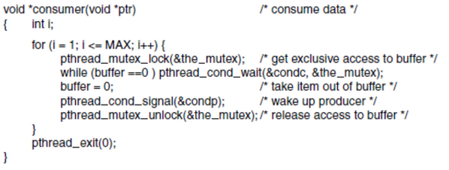

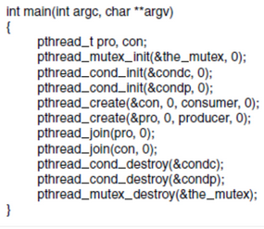

###### Monitors

Programming with semaphores and mutexes can be quite challenging

The concept of monitor was introduced in order to overcome some of these difficulties

A monitor is a collection of procedures, variables and data structures, grouped in a module

Processes can call the procedures in a monitor as needed, but cannot access its internal data structures

Only one process can be active in a monitor at any given time (thus ensuring mutual exclusion)

• Monitors are programming language constructs, so the compiler will generate the necessary

instructions to achieve this property (rather than the programmer)

• Critical regions can be turned into monitor procedures to achieve mutual exclusion

Only some programming languages implement this concept, for example, Java does, but C does not.

In Java, a monitor can be implemented by creating a class that contains methods that use the keyword synchronized

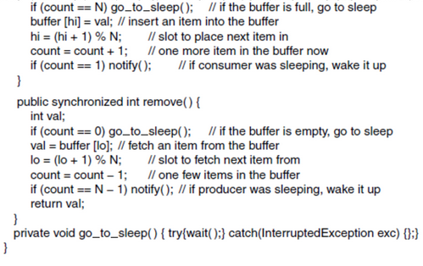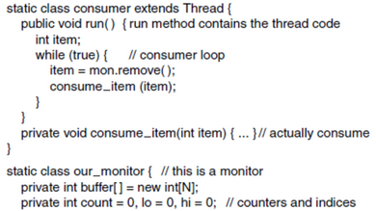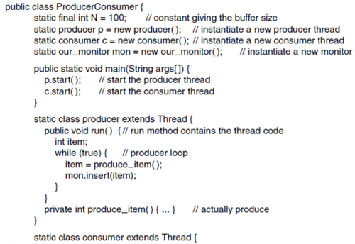

###### Message Passing

This uses two system calls – send and receive:

send(destination, &message);

receive(source, &message);

Receive can have source as ANY

The process invoking receive gets blocked if no message is available.

It can also return immediately with an error code.

Different machines normally communicate via a network, hence some messages can be lost

A protocol can be defined:

– The receiver can send back an acknowledgement message – if the sender does not receive it after some time, it retransmits the message

– Retransmissions also need to be recognized to prevent duplication – this can be achieved via a

sequence number

In the presence of more than one machine there is a need for authentication

Performance is another matter that needs to be considered as sending messages takes more time than in-machine operations

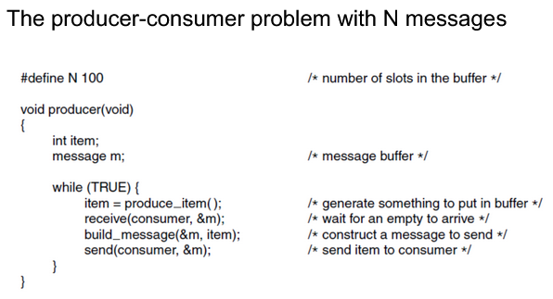

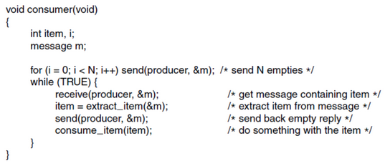

###### Barriers

Some applications rely on phases

• No process can move into the next phase before all processes are ready to do so

• These phases are separated by barriers

• A process arriving at a barrier is blocked until all processes have reached the barrier, which works as a synchronization mechanism

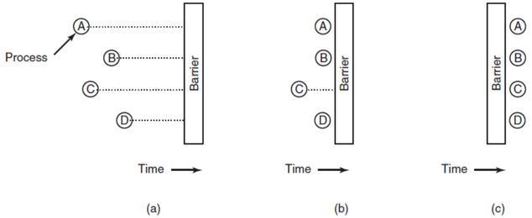

###### RCU (Read-Copy-Update)

Inserting a node in the tree and then removing a branch—all without locks

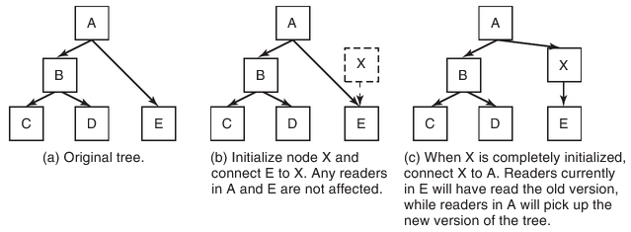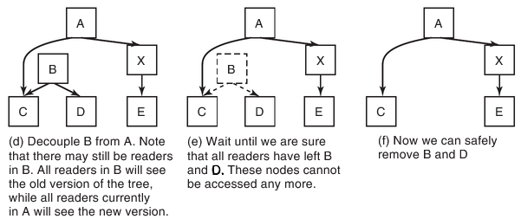

The Dining Philosophers Problem

Five philosophers are seated around a circular table and each has a plate of spaghetti

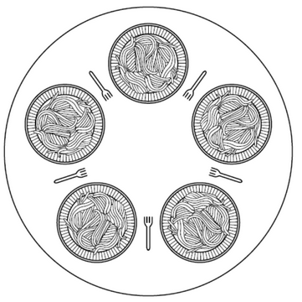• The spaghetti is so slippery that two forks are needed to eat it

• However: between each plate there is only one fork

These philosophers only:

– Eat; or

– Think (and get hungry)

When they are hungry, they try to pick up the left and right forks,

one at a time, in either order

If successful, the philosopher will eat for a while, then put down the forks

and go back to thinking

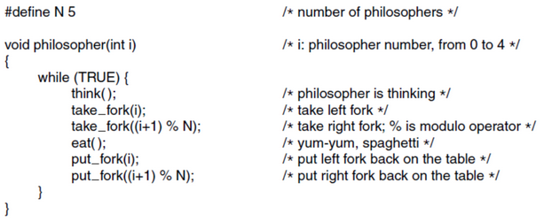

What happens if all take the left fork simultaneously?

Another attempt:

What if, after taking the left fork, a philosopher puts it down if it is not possible to take the right, waits for

some time and tries again?

* there would be a possibility that they always get the left fork, then put it down as there is no right fork available, and then pick the left one again
* starvation: the programs continue to run but fail to do progress

Random time wait?

– Limits the chance of problems

– Works in Ethernet LAN (and other protocols)

– Not always applicable (critical systems)

How about a binary semaphore?

It works, but only one philosopher can eat at one given time despite there being three forks left

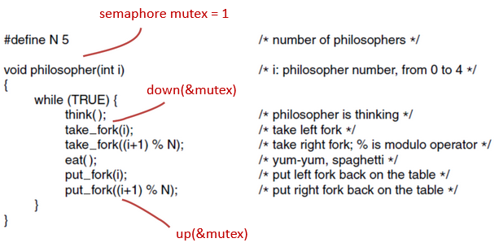

A deadlock-free solution whilst maximizing resource usage exists but is more complex:

– Store state for all philosophers (eating, thinking, hungry)

– A philosopher can only eat if none of its immediate neighbors are eating

– Maintain array of semaphores to block hungry philosophers that cannot eat yet

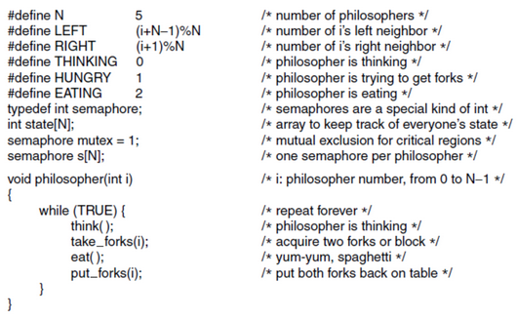

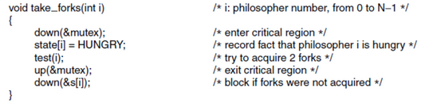

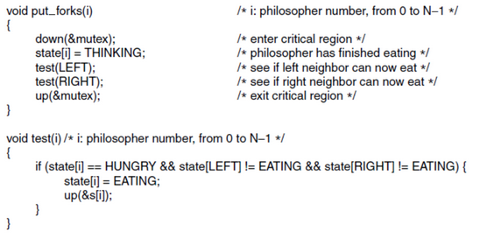

The Readers and Writers Problem

Consider a database and two kinds of processes in execution: readers and writers

– readers extract information from the database

– writers update the database

Any number of readers can read the database in parallel

When a writer accesses the database, no one can have access, not even readers

The database is protected by the semaphore db; values of db are either

• 1 (access allowed); or

• 0 (not allowed)

The first reader comes and does down(&db)

Another reader comes - it should not do down(&db) or it will be blocked!

Solution:

– the variable rc contains the number of readers that are currently reading the database

– only the first reader executes down(&db)

– the last leaving reader executes up(&db)

– the semaphore mutex controls access to rc

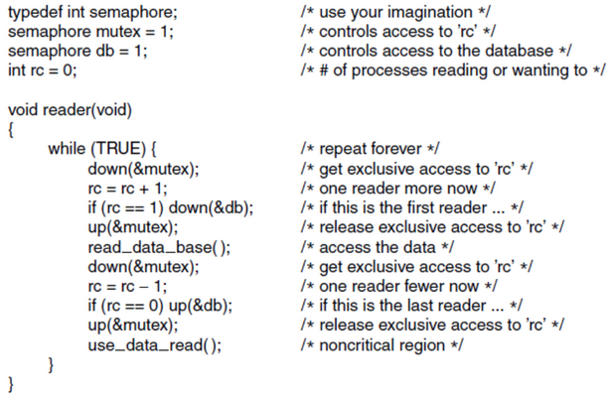

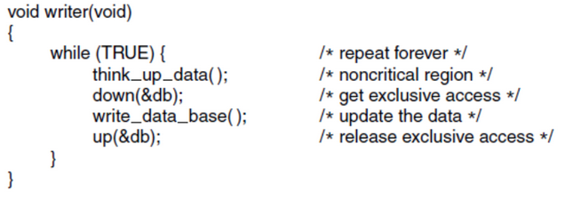

Issue: in this solution, readers have a priority

If a writer is sleeping on db but readers keep being admitted;

some finish using the database and leave but new readers arrive

hence rc does not fall to 0, readers do not do up(&db) and the writer keeps waiting.

# Scheduling

In an environment where multiple processes or threads compete for resources, there is a need for scheduling. A scheduler is the operating system component that implements a scheduling algorithm that determines which process/thread to run next.

## Types of Scheduling

* Admission scheduling - making decisions on which jobs to admit to the system and when
* Memory scheduling - making decisions on which processes should be kept in memory and which

ones should be swapped out onto disk

* CPU scheduling - deciding which of the ready processes to run next

CPU scheduling

In addition to selecting the right process to run, the scheduler must also make efficient use of the CPU as process switching is expensive

Switching normally requires:

1. Switch from user mode to kernel mode

2. Save the current process state

3. Save memory map for the current process

4. Select new process

5. Load memory map for the new process

6. Place the new process into execution

Processes normally alternate bursts of computing with (disk or network) I/O requests

– Often, the CPU runs for a while without stopping, then a system call is made to access a file

– When the system call completes, the CPU computes again until it needs more data or has to write more

data, and so on

Some I/O activities count as computing

– For example, when the CPU copies bits to a video RAM to update the screen, it is computing, not I/O,

because the CPU is in use

From a process behavior standpoint, the term I/O is normally associated to when a process enters the blocked state waiting for an external device to complete its work

There are two types of processes:

– Compute-bound (CPU-bound) processes: spend most of their time computing

– I/O-bound processes: spend most of their time waiting for I/O

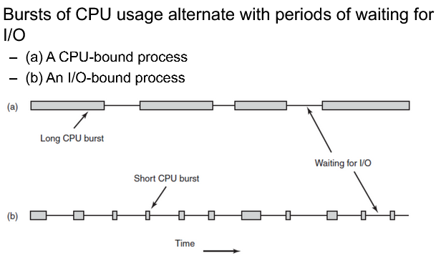

When to schedule

– On process creation: parent or child?

– On process termination

– On process blocking (the reason may play a part in the decision):

• I/O

• Semaphore

• …

– On I/O interrupt

– On periodic clock interrupt

## Scheduling Methods Classes

Nonpreemptive scheduling algorithms pick a process to run and then just let it execute until it blocks or voluntarily releases the CPU

Preemptive scheduling algorithms pick a process and let it run for a maximum of some fixed time

Nonpreemptive Scheduling

Even if it runs for many hours, the selected process will not be suspended

No scheduling decisions are made during clock interrupts

– After clock-interrupt processing has been finished, the process that was running before the interrupt is resumed (unless a higher-priority process was waiting for a now-satisfied timeout)

Preemptive Scheduling

If the selected process is still running at the end of the interval, it is suspended and the scheduler picks another process to run

Requires having a clock interrupt occur at the end of the interval to give control of the CPU back to the scheduler

## Categories of Scheduling Algorithms

Goals of all systems

– Fairness

– Policy enforcement

– Balance

Batch

– Still in widespread use in the business world for doing payroll, inventory, and other periodic tasks

– No users impatiently waiting at their terminals for a quick response to a short request

– Nonpreemptive algorithms, or preemptive algorithms with long time intervals, are often acceptable

Goals: Throughput, Turnaround time, CPU utilization

Interactive

– Preemption is essential to keep one process from sticking with the CPU and denying service to others

– Servers also fall into this category, since they normally serve multiple (remote) users

Goals: Response time, Proportionality

Real time

– Although it is counter-intuitive, preemption is sometimes not needed as processes usually do not

run for long periods of time (work and block quickly)

– The difference with interactive systems is that real-time systems run only programs that are

intended to further the application at hand

Goals: Meeting deadlines, Predictability

Scheduling in Batch Systems

• First-Come, First-Served

• Shortest Job First

• Shortest Remaining Time Next

#### First-Come, First-Served

– Single queue of ready processes, the order in the queue determines which one gets the CPU

– Jobs are not interrupted (nonpreemptive)

– Easy to understand and implement

– Not very efficient (CPU-bound vs. I/O-bound)

#### Shortest Job First

– Nonpreemptive

– Applicable when there is good understanding of how much time jobs take to run

– The shortest job is chosen amongst equally important jobs currently in the input queue

Consider a mainframe system without multiprogramming

• We have four jobs, A, B, C, and D in the input queue

• Suppose that we know their estimated running times: 8, 4, 4, and 4 minutes, respectively

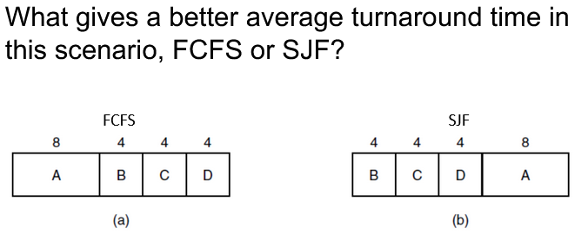Which gives better average turnaround time?  
The average turnaround time can be

proved to be optimal for shortest job first

#### A screenshot of a math test Description automatically generatedComputing Average Turnaround Time

(4a + 3b + 2c + d)/4 – Minimal if a ≤ b ≤ c ≤ d

#### Shortest Remaining Time Next

– Preemptive version of Shortest Job First

– The time must be known in advance as in that case

– Short jobs get good service

Scheduling in Interactive Systems

• Round-Robin Scheduling

• Priority Scheduling

• Multiple Queues

• Shortest Process Next

• Guaranteed Scheduling

• Lottery Scheduling

• Fair-Share Scheduling

#### Round-Robin Scheduling

Each process is assigned a time interval, called its quantum, during which it is allowed to run

– If the process is still running at the end of the quantum, the CPU is preempted and given to another

process, and the previous one is put on the end of the list

– If the process has blocked or finished before the quantum has elapsed, the CPU switching is done when the process blocks

– Easy to implement

Issues:

– Setting the quantum too short causes too many process switches and lowers the CPU efficiency

– Setting the quantum too long may cause poor response to short interactive requests

#### Priority Scheduling

– Jobs are not always of the same importance

– Each process is assigned a priority and the highest priority one is selected to run

– To prevent high-priority processes from running indefinitely, the scheduler may decrease the priority of

the currently running process at each clock interrupt

– Alternatively, each process may be assigned a maximum time quantum that it is allowed to run

#### CTSS Scheduler

– Priority classes and multiple queues

– Gives a number of quanta depending on the priority

– When a process uses all allocated quanta, it drops a class

#### Shortest Process Next

– Similar to the nonpreemptive batch version

– Uses an estimation of the process time based on past behaviour

#### Guaranteed Scheduling

– Give a certain level of service according to resources

– For instance, promising 1/n CPU time to a process if there are n processes in ready state

– Requires logging history

#### Lottery Scheduling

– “lottery tickets” are given to each process

– Scheduler randomly selects one ticket and the process holding it can run

– Important processes can get multiple tickets

– Cooperating processes can exchange tickets

#### Fair-Share Scheduling

– To prevent users that have more processes to possibly have more CPU time (as it happens with Round Robin), this algorithm can take into account the process owner

– Each user is allocated a fraction of CPU time

– Other sharing techniques can be used

Scheduling in Real-Time Systems

Time plays an essential role

Categories:

– Hard real time

– Soft real time

– Periodic or aperiodic

A system may have to respond to multiple periodic event streams, and it may not be possible to handle all

– If there are m periodic events and event i occurs with period Pi and requires Ci seconds of CPU time to

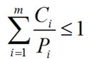handle each event, the scenario is schedulable if the following formula is satisfied

## Policy vs. Mechanism

In the previous algorithms (in their standard form), the scheduler has limited information to take decisions

• In some cases, the processes have relevant data about how scheduling should take place

One way to solve this issue is to separate the scheduling mechanism from the scheduling policy

This way, the scheduling algorithm can be parameterized, and the parameters can be set by user processes

Processes can, for instance, change priorities for their child processes

• Processes get some control about how children are scheduled, but still the scheduling mechanism is in the kernel

## Thread Scheduling

Scheduling of threads depends on whether these are at user-level or kernel-level

With user-level threads, the scheduler is only in control of processes, and within these, the

threads are scheduled by each owner process

– If a thread is blocked by I/O, the owner process is too

Kernel-level threads are scheduled by the scheduler as processes

– Blocking a thread does not necessarily block the owner process, but context switches are more costly

(full context switch)

# Memory Management

Memory needs to be managed due to size, speed, volatility/non-volatility and cost

Parkinson’s Law: ‘‘Programs expand to fill the memory available to hold them.’’

To make good use of the available technology (vs. cost), the concept of memory hierarchy was formed

• This can be abstracted by the operating system by the memory management component

## No Memory Abstraction

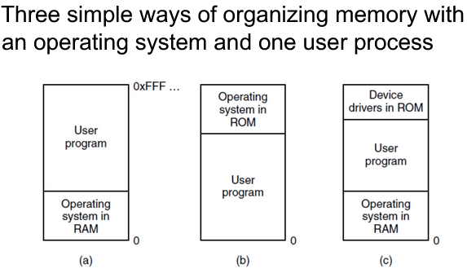Early computers had no memory abstraction; programs had access to the physical memory

Swapping

the operating system can save the entire contents of memory to disk, then load the next program

(thus always only having one program at a time in memory)

Divide the memory into chunks for each loaded program and prevent illegal access

Static relocation

As the previous, but changing programs on the fly by changing the accessed memory addresses to the actual place they were reserved on

– Slow and complex approach

## Memory Abstraction: Address Spaces

Running multiple processes without interference requires:

– Protection

– Relocation

An address space consists of the addresses that a process can use

– Abstract memory

– Each process has its own address space

Examples of address spaces from other domains:

– Phone numbers

– IP addresses (v4 vs. v6)

– Ports

How can address X for a program mean a different physical location than for a different program?

• Example: base and limit registers (dynamic relocation)

Base and Limit Registers

Programs are loaded where there is room

When a process is run:

– the base register is loaded with the physical address where its program begins in memory

– the limit register is loaded with the length of the program

– Every time a process references memory, the address is added to the value of the base register

– If a reference is made above base + limit, a fault is generated

Swapping

There are many cases in which the physical memory is not sufficient to hold all programs

One strategy to address this is swapping:

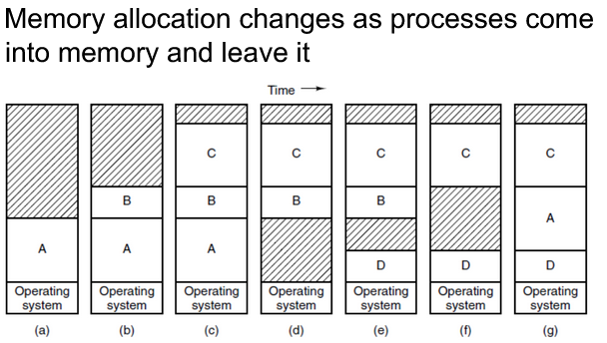– bringing in a process in its entirety

– running it for a while

– then putting it back on the disk

Processes can grow as they run

• Normally extra memory is allocated to

prevent frequent swapping of processes

no longer fitting in memory

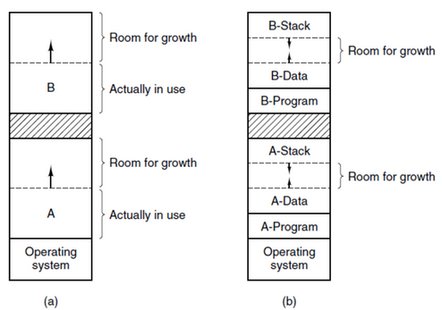

## Memory Management with Bitmaps

Bitmaps

– Memory is divided into allocation units

– Each allocation unit is represented by a bit in the bitmap, indicating if it is free or not

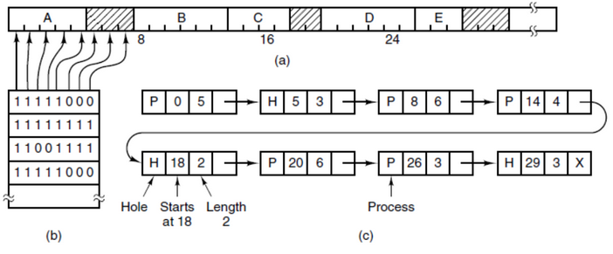

– The smaller the allocation unit, the larger the bitmap

– A large allocation unit might waste significant memory if processes’ sizes are not multiples of the unit’s size

– Simple implementation

– Searching for k consecutive empty units can be slow

Linked Lists

– Maintain a linked list of allocated and free memory segments

– The segment list can be kept sorted by address

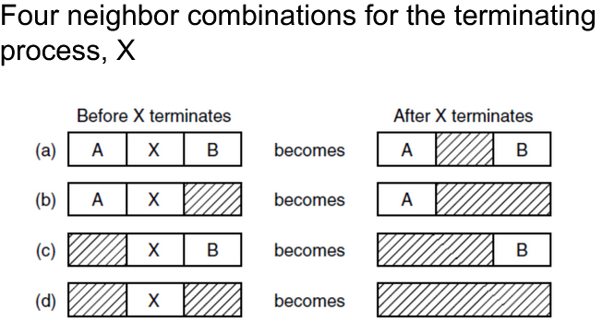

## Memory Management Algorithms

First fit

– The memory manager scans along the list of segments from its start until it finds a hole that is big

enough

– The hole is then broken up into two pieces, one for the process and one for the unused memory, except in the unlikely case of an exact fit

– It is a fast algorithm because it searches as little as possible

Next fit

– Works as first fit but starts to scan from the last segment where it found a hole for the previous process

– Simulations showed it has slightly worse performance than first fit

Best fit

– Searches the entire list, from beginning to end, and takes the smallest hole that is adequate

– Finds the best match for the process size

– Slower than first fit as it always scans the whole list

– Usually actually results in more wasted memory than the previous algorithms as it tends to leave small, unusable, holes

Worst fit

– Searches the entire list, from beginning to end, and takes the largest hole

– The remaining hole from that segment may still be big enough for other processes

– Simulations have shown that worst fit is not a very good idea either

Quick fit

All previous algorithms can be improved by storing separate lists for processes and holes, possibly ordered by size

– This means the algorithms only need to scan holes

– Uses added time to move segments between lists when process termination or swapping occurs

Quick fit

– Maintains separate lists for some of the more common sizes requested

For example, it might have a table with n entries, in which the first entry is a pointer to the head of a list of 4-KB holes, the second entry is a pointer to a list of 8-KB holes, and so on

– Finding a hole of the required size is extremely fast

– It has the same disadvantage as all schemes that sort by hole size

when a process terminates or is swapped out, finding its neighbors to see if a merge with them is possible is expensive

– If merging is not done, memory will quickly fragment into a large number of small holes into which no processes fit

## Virtual Memory

There is a need to run programs that are too large to fit in memory

– Either by themselves or together with others

• Solution adopted in the 1960s, split programs into little pieces, called overlays

– Kept on the disk, swapped in and out of memory

– Required the programmer to design the application this way

Virtual memory – each program has its own address space, broken up into chunks called pages

Each page is a contiguous range of addresses

Pages are mapped onto physical memory

– However, not all pages for a program need to be in memory simultaneously

When a program references a part of its address space that is in physical memory, the hardware

performs the necessary mapping on the fly

When the program references a part of its address space that is not in physical memory,

the OS is alerted to go get the missing piece and re-execute the instruction that failed

Memory addresses can be generated using indexing, base registers, segment registers, etc

– These are called virtual addresses and form the virtual address space

– The Memory Management Unit (MMU) maps virtual addresses onto physical memory

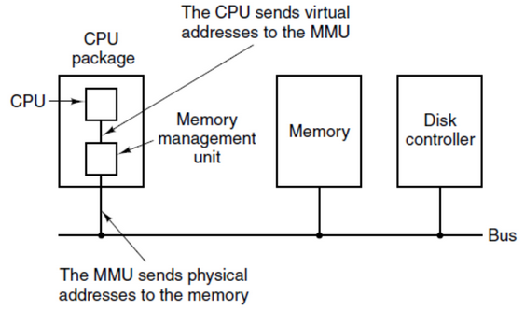

Paging

The page table maps virtual page number to physical page number

• Every page begins on a multiple of 4096 and ends 4095 addresses higher

What happens when an unmapped address is accessed (e.g. 32780)?

– The MMU notices it is unmapped and causes the CPU to trap to the OS – page fault

– The OS saves a page frame to disk (if not already there) and fetches the requested page into the one

that was freed

– The map is updated and the trapped instruction is restarted

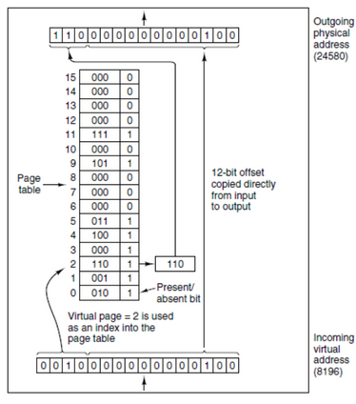

The internal operation of an MMU with 16 4-KB

pages

– The virtual page number is used as an index

into the page table to find the entry for that

virtual page

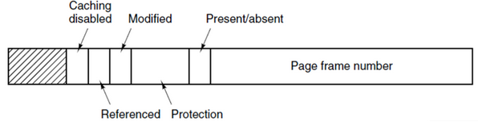

A typical page table entry

– Protection: 1 bit for r/rw or 3 bits for r|w|x

– Modified: changed since loaded (dirty)

or not (clean)

– Referenced: set when a page is referenced,

either for reading or for writing

– useful to determine which pages

are evicted

#### Speeding-Up Paging

Major issues faced:

1. The mapping from virtual address to physical address must be fast

2. If the virtual address space is large, the page table will be large

Observation:

– Most programs tend to make a large number of references to a small number of pages, and not the other way around

– Only a small fraction of the page table entries are heavily read; the rest are barely used at all

##### A table with numbers and text Description automatically generatedTranslation Lookaside Buffers

TLBs can be used to speed up virtual-to-physical

address translation over the original page-table-

in-memory scheme

##### Multilevel Page Tables

Another problem is how to deal with very large virtual address spaces

A strategy is to use a multilevel page table

– Prevents having all of the page table in memory

– A top level page table references a second level, etc.

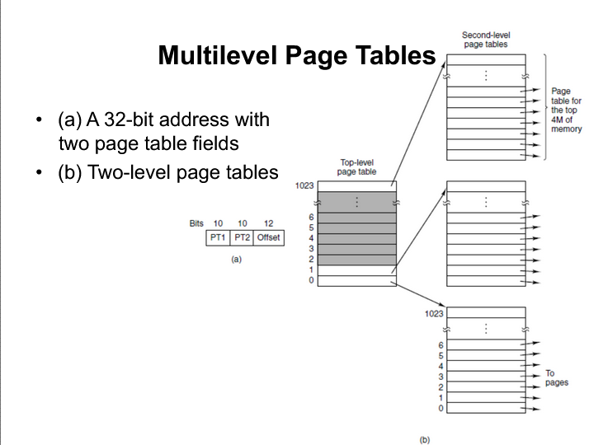

##### Inverted Page Tables

Goal: Prevent having many levels like potentially could occur in the previous approach

The page table can have one entry per frame in real memory, instead of one per virtual page

(inverted page table)

Saves space but virtual-to-physical translation becomes much harder

– A TLB can minimize this

– It is also possible to have a hash table hashed on the virtual address

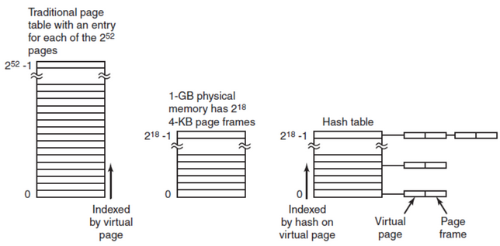

#### Page Replacement

When a page fault occurs, the operating system has to choose a page to evict (remove from memory) to make room for the incoming page

If the page to be removed has been modified whilst in 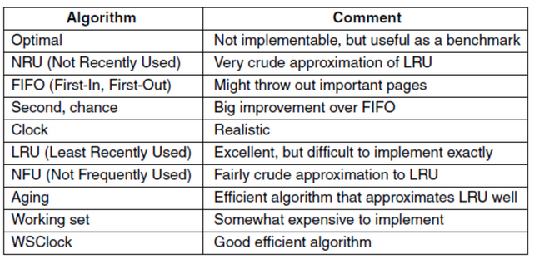memory, it must be rewritten to the disk

If, however, the page has not been changed (e.g., it contains program text), the disk copy is already up to date, so no rewrite is needed.

– The page to be read in just overwrites the page being evicted (since it is already in the disk)

##### Page Replacement Algorithms

• Optimal algorithm

• Not recently used algorithm

• First-in, first-out (FIFO) algorithm

• Second-chance algorithm

• Clock algorithm

• Least recently used (LRU) algorithm

• Working set algorithm

• WSClock algorithm

###### Optimal Algorithm

At the moment that a page fault occurs, a set of pages will be in memory

One of these will be referenced in the next instruction, and other pages will only be referenced in some time

Each could be labeled with the number of instructions until it is referenced

The optimal page replacement algorithm says that the page with the highest label should be removed

Only one disadvantage…it is unfeasible

How can the OS know of all future references?

Even on a second run, a program may not run exactly the same

Still, it can be used for benchmarking algorithms

###### Not Recently Used Algorithm

At page fault, the system inspects pages

Categories of pages are kept based on the current values of their R and M bits:

– Class 0: not referenced, not modified

– Class 1: not referenced, modified

– Class 2: referenced, not modified

– Class 3: referenced, modified

The NRU algorithm removes a page at random from the lowest nonempty class

– Simple, yet moderately efficient

###### First-In, First-Out (FIFO) Algorithm

A list of pages is kept where the order corresponds to the order in which they were placed in memory

• On a page fault, the page at the head is removed and the new page gets added to the tail of the list

Problem

– The oldest page may still be useful - FIFO is rarely used as such

###### Second-Chance Algorithm

(a) Pages sorted in FIFO order

(b) Page list if a page fault occurs at time 20 and A has its R bit set. The numbers above the

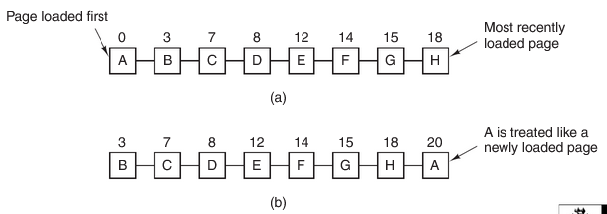pages are their load times.

(R is cleared for A, if R was 0,

A would have been removed)

###### Clock Page Replacement Algorithm

– More efficient than second chance since it does not move around so many pages

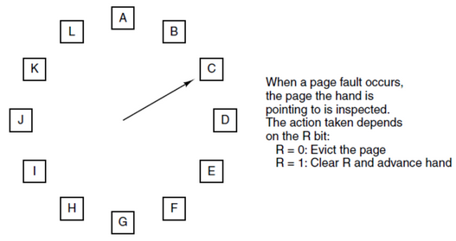

###### Least Recently Used Algorithm

Observation:

– Pages that have been heavily used in the last few instructions will probably be heavily used again soon

• Strategy:

– Throw away the page that has been unused for the longest time

• Problem: It is Expensive; requires a list of all pages in memory, and this needs to be updated on every memory reference

Simulating LRU in Software - Aging

The aging algorithm simulates LRU in software. Shown are six pages for five clock ticks. The five clock ticks are represented by (a) to (e). Each page has a counter that gets the value of its R bit in the left hand side after each tick, thus showing recent usage.

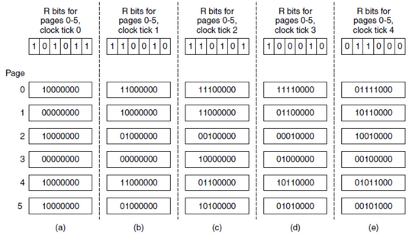

###### Working Set Algorithm

In the purest form of paging, processes are started up with none of their pages in memory

• As soon as the CPU tries to fetch the first instruction, it gets a page fault, causing the operating system to bring in the page containing the first instruction

Other page faults for global variables and the stack usually follow quickly

• After a while, the process has most of the pages it needs and settles down to run with relatively few page faults.

• This strategy is called demand paging

Programs normally exhibit a locality of reference

At any phase of execution, the process references a small fraction of its pages

The set of pages a process is currently using is called its working set

– If all of it is in memory, the process will cause a low number of faults until it moves to another execution

phase

Paging systems can load the current working set once a process gets swapped back into physical memory (working set model, prepaging)

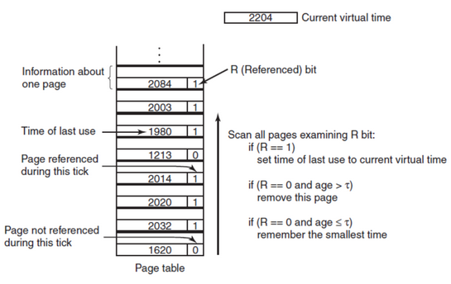

(Virtual time is the amount of time the process

has used the CPU for, since it started)

(If all are in the working set, the one with the

greatest age & R==0 is evicted)

(age = current virtual time – time of last use)

(remember smallest time = set time of last use

to current virtual time)

###### WSClock Algorithm

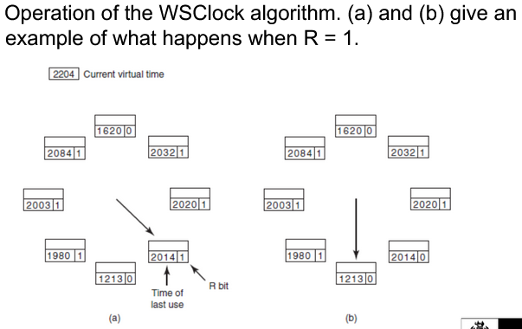

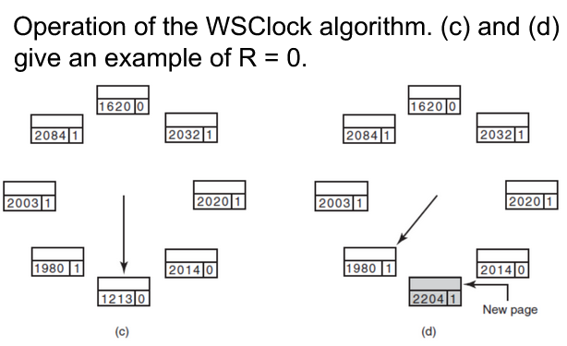

(M bit not shown in picture)

#### A group of rectangular objects with text Description automatically generated with medium confidenceDesign Issues for Paging Systems

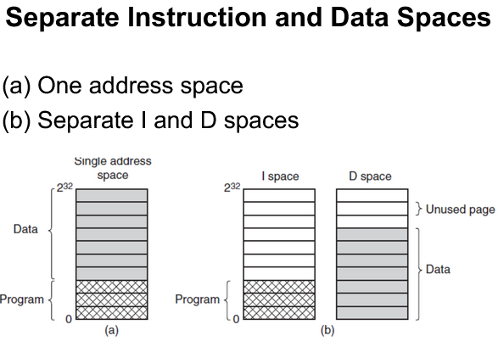

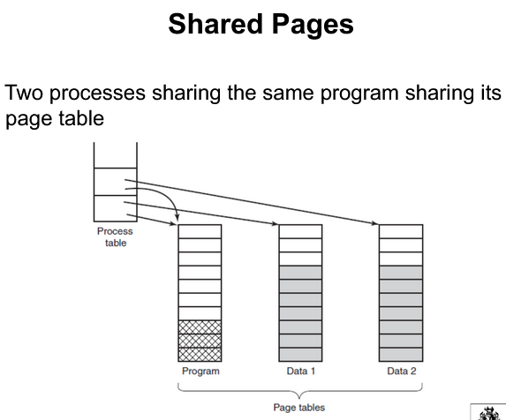

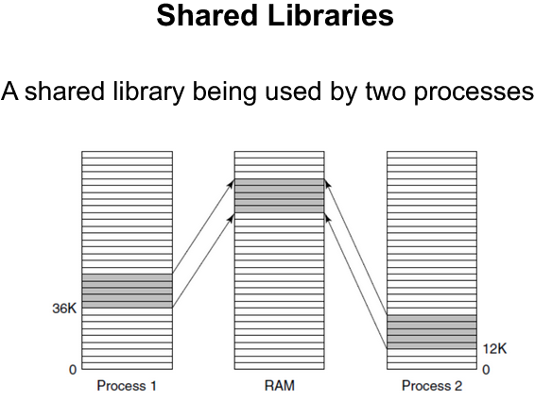

Page Fault Handling

• The hardware traps to the kernel, saving the program counter on the stack

• An assembly code routine is started to save general registers and other volatile info

• The system determines that a page fault has occurred, and tries to discover which virtual

page is needed

Once the virtual address that caused a fault is known, the system checks to see if the address is valid and the protection matches the access

• If the frame selected is dirty, the page is scheduled for transfer to disk, context switch takes place, suspending faulting process

As soon as the frame is clean, the OS looks up the disk address where the needed page is, and schedules a disk operation to bring it in

• When a disk interrupt indicates the page has arrived, the tables are updated, and the frame is marked as being in normal state

The faulting instruction is backed up to the state it had when it began and the program counter is reset

• The faulting process is scheduled, and the OS returns to the routine that called it

• The routine reloads registers and other state information, and returns to user space to continue execution

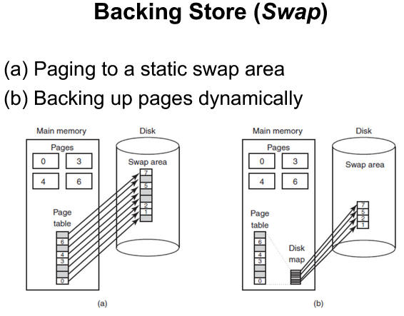

Segmentation

Examples of tables generated by a compiler:

– The source text being saved for the printed listing

– The symbol table, names and attributes of variables

– The table containing integer and floating-point constants used

– The parse tree, syntactic analysis of the program

– The stack used for procedure calls within compiler

In a one-dimensional address space with growing tables, one table may bump into another

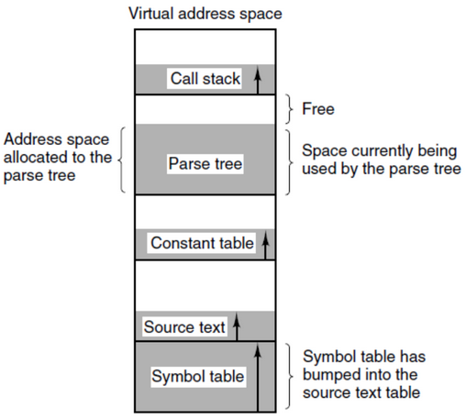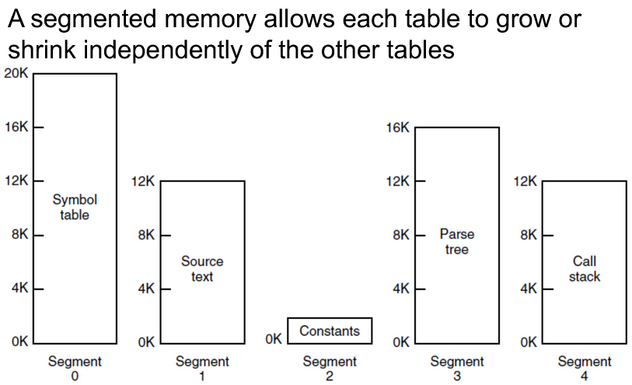

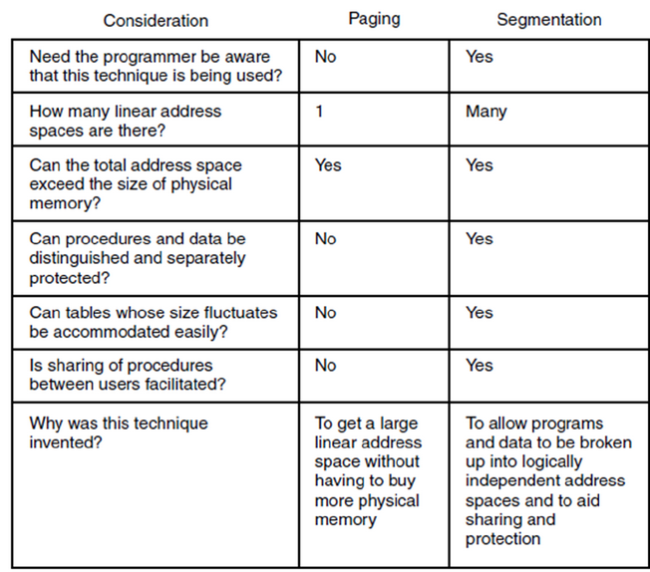

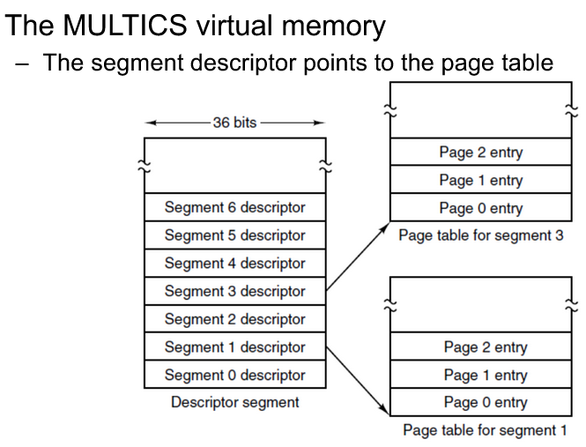

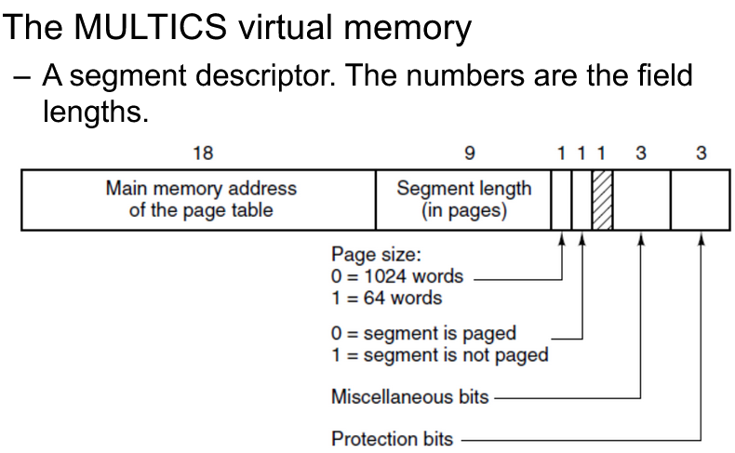

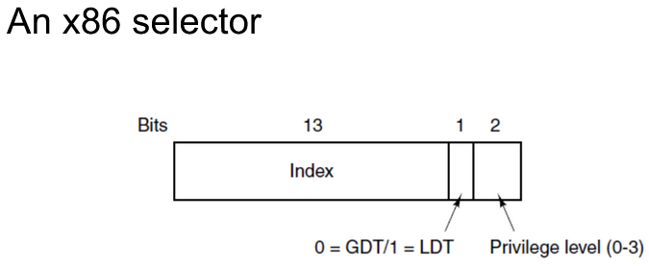

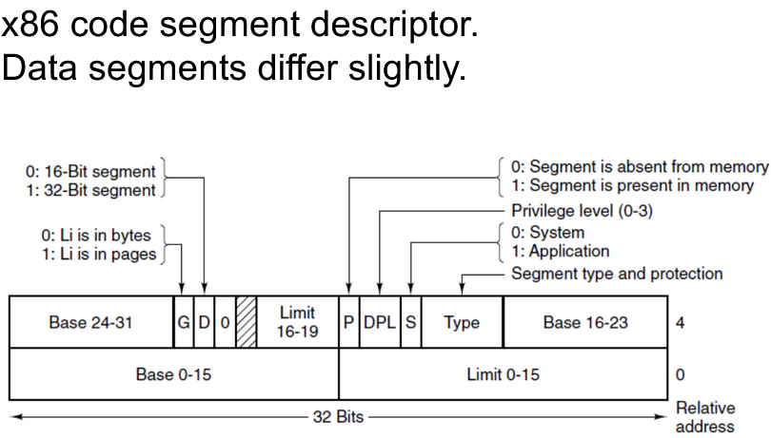

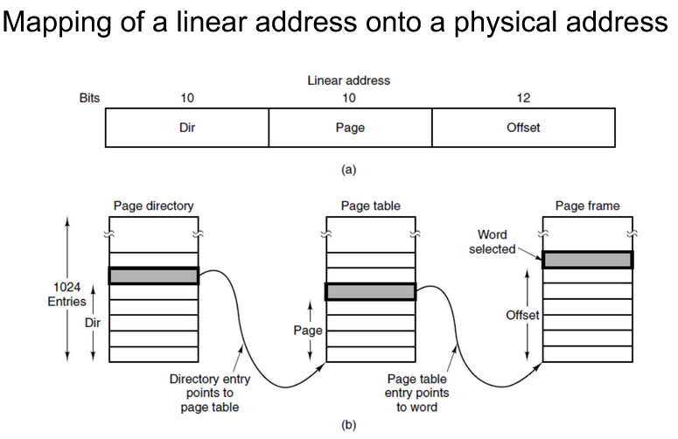

# File Systems

Need:

Processes have a limited amount of space where they can keep their data in memory

(virtual address space)

• When a process ends, its information is lost

• In some cases, multiple processes need to access the same data, possibly at the same time

Essential requirements for long-term information storage:

1. It must be possible to store a very large amount of information

2. Information must survive process termination

3. Multiple processes must be able to access information concurrently

As a simplification, a disk can be seen as a linear sequence of fixed-size blocks supporting two operations:

– Read block k

– Write block k

Questions that quickly arise:

– How do you find information?

– How do you keep one user from reading another user’s data?

– How do you know which blocks are free?

The concept of file is another abstraction that OSes give us, in this case to address storage

– Together with processes/threads and address spaces, these form some of the main concepts regarding operating systems

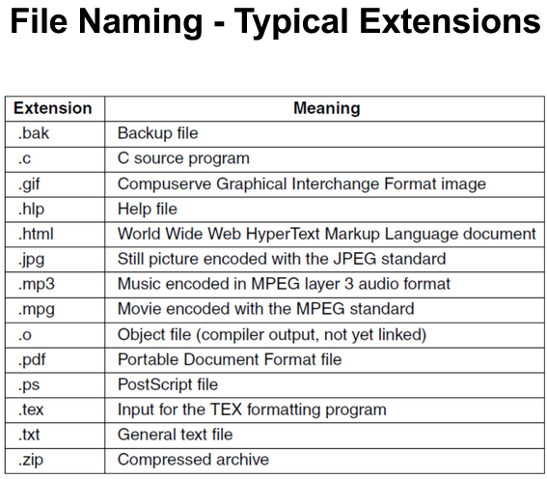• Files are logical units of information created by processes

Processes can access existing files and create new ones

Information stored in files is persistent

– Process creation and termination do not affect them

Files are managed by the operating system:

– Structure

– Naming

– Access

– Protection

– Implementation

The OS component that handles files is called file system

Naming provides an abstract way for applications to use files

The naming rules vary depending on the OS

Many support (or encourage) a two part name separated by a dot (.):

– Main name

– Extension

Files can be structured in a number of ways:

– Unstructured sequence of bytes

• The OS does not care about what is in the file

• UNIX, Linux, OS X and Windows

– Files containing fixed-length records

• Reads and writes operate at record granularity

• Used in old operating systems (e.g. punched card input)

– Tree of variable-length records

• Each record has a key field, which is used to sort the tree

• Elements can be fetched by key regardless of position

• Used in some mainframe computers

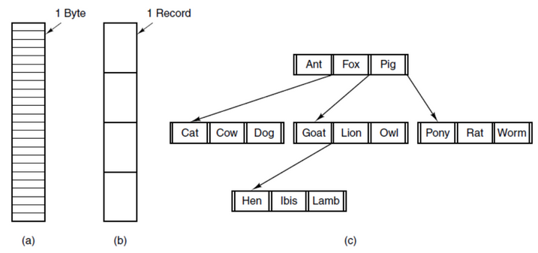

Operating systems support different types of files, for example:

– Regular files – contain user data

– Directories – system files for maintaining structure

– Character special files – used for serial I/O devices

– Block special files – used to model disks

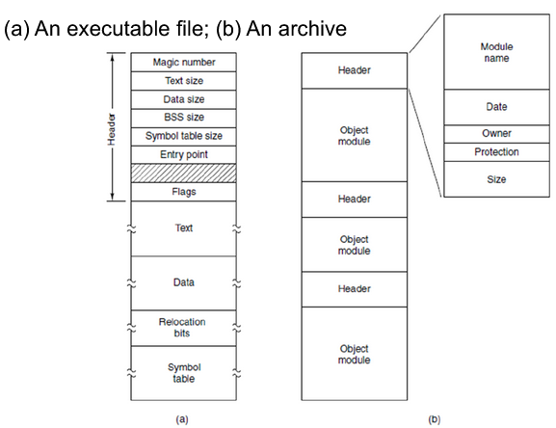

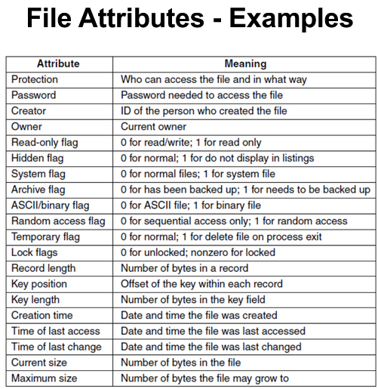

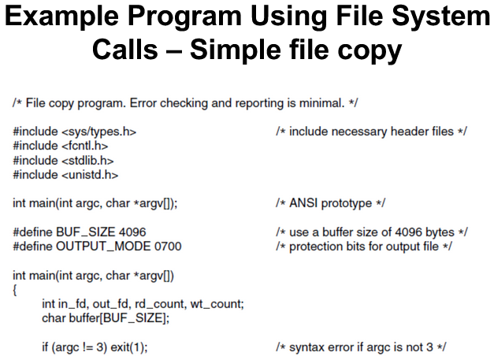File Operations:

• Create

• Delete

• Open

• Close

• Read

• Write

• Append

• Seek

• Get attributes

• Set attributes

• Rename

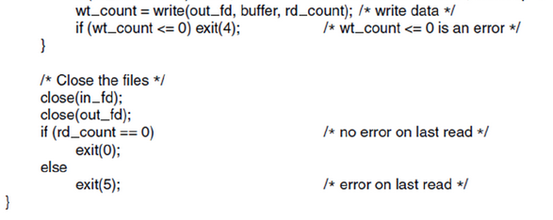

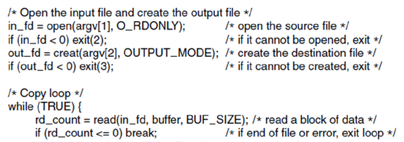

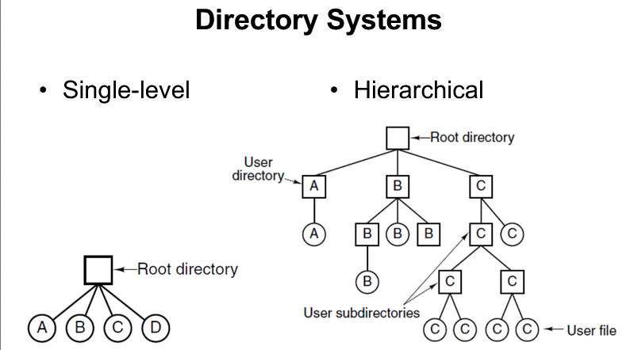

Directory Operations:

• Create

• Delete

• Opendir

• Closedir

• Readdir

• Rename

• Link

• Unlink

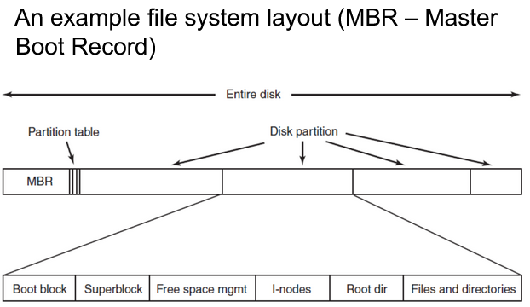

## Implementing Files

Contiguous Layout

Advantages: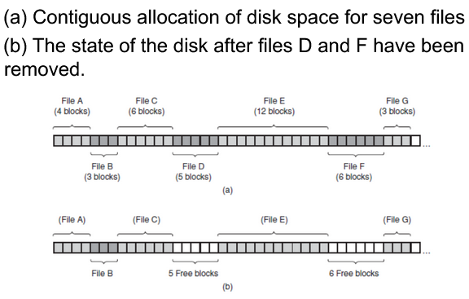

– Simple

– Fast reads

Disadvantages:

– Fragmentation

Usage:

– CD-ROMs, DVDs, Blu-rays

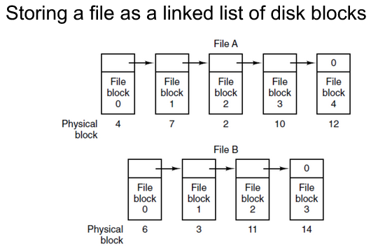Linked List Allocation

Advantages:

– No inter-file fragmentation

– Sequential reads are simple

Disadvantages:

– Random access is very slow

– Data storage in blocks is not a power of two

(as the pointer takes a few bytes)

It is less efficient as programs normally read

and write power of two sized blocks

Linked List – Table in Memory

Advantages:

– The whole block is available for data

– Random access is quicker as the

chain is all in memory

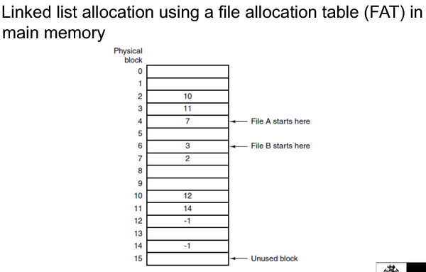

Disadvantages:

– The entire table must be in memory

Does not scale well

For a 1 TB disk this can mean

3 GB of RAM just to hold the FAT

Usage:

– MS-DOS

(and still supported in Windows)

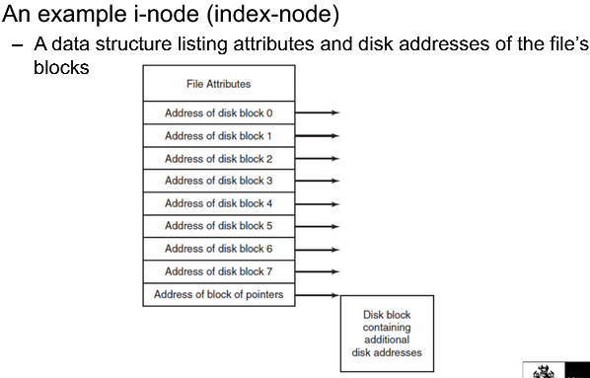I-nodes

Advantages:

– i-nodes only need to be in memory

if the corresponding files are open

– Does not depend on disk size

Disadvantages:

– A chain of i-nodes might be

necessary for big files. Still

using much less space than a FAT

Usage:

– UNIX, Windows NTFS

## Implementing Directories

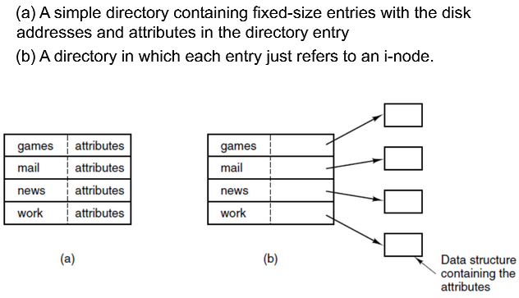

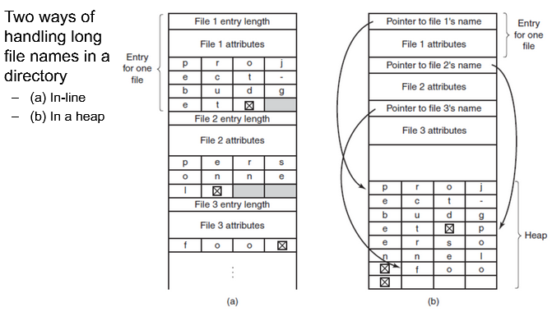

## Virtual File Systems

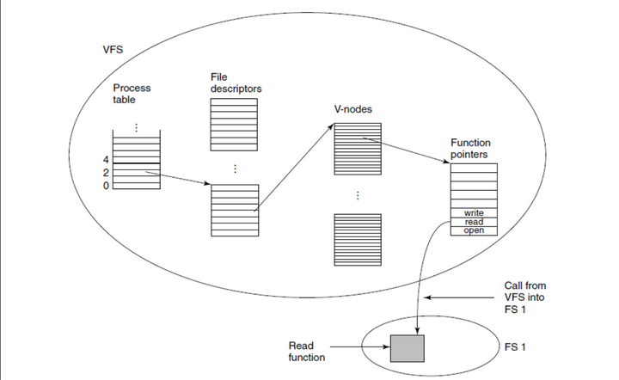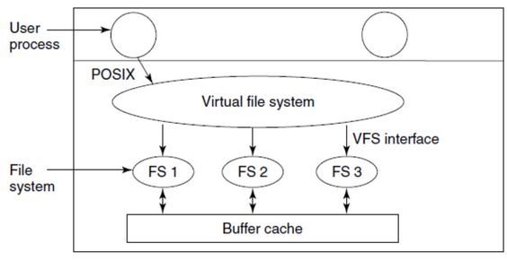

## Disk Quotas

Quotas are kept track of on a per-user basis in a quota table

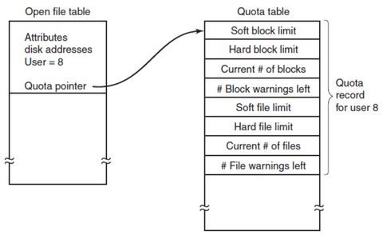

## Example File Systems

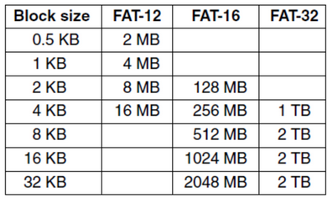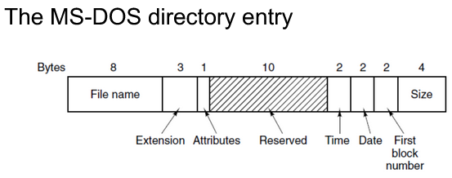The MS-DOS File System

Maximum partition size for different block sizes. The empty boxes represent forbidden combinations.

The UNIX V7 File System

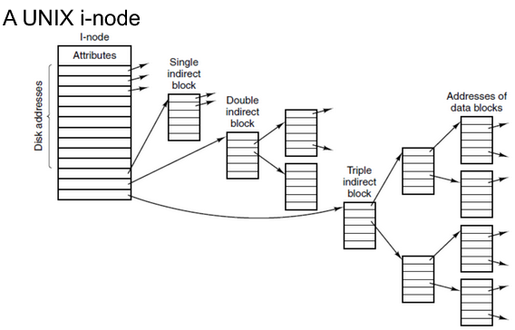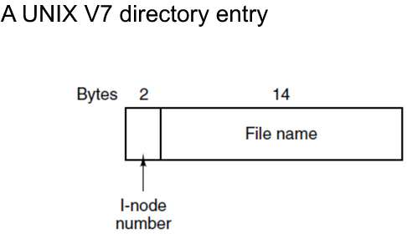

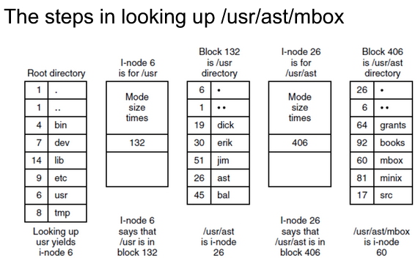

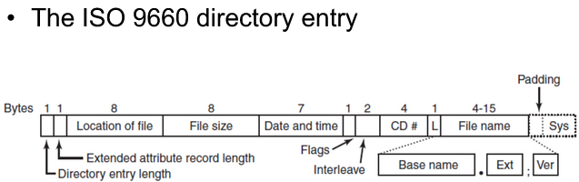The ISO 9660 File System

Rock Ridge Extensions

• PX - POSIX attributes.

• PN - Major and minor device numbers.

• SL - Symbolic link.

• NM - Alternative name.

• CL - Child location.

• PL - Parent location.

• RE - Relocation.

• TF - Time stamps.

Joliet Extensions

• Long file names

• Unicode character set

• Directory nesting deeper than eight levels

• Directory names with extensions

# Deadlocks

Many resources in a computer system can only be used by one process at a time

– Printers, some backup media, system tables, database records, etc

Operating systems need to grant exclusive access for these cases

Some applications need to access several of these resources:

– E.g. Two different processes (A and B) need to save scanned documents to a DVD:

However, A can request access to the scanner at the same time as B requests access to the DVD, hence none can get their missing resource next: Deadlock!

Deadlocks can also occur across machines or with more than just two processes/devices

## Preemptable and Nonpreemptable Resources

Preemptable resource:

– Can be taken away from the process that is using it without causing issues

– e.g. a process can be temporarily removed from memory

Non-preemptable resource:

– Cannot be taken away from the process that is using it without potentially causing failure

– e.g. interrupting a record (burn) operation on a DVD will usually cause it to fail

Normally the resources which are susceptible to be involved in deadlocks are non-preemptable

In this context, the sequence of events required to use a resource is:

1. Request the resource

2. Use the resource

3. Release the resource

## Resource Acquisition

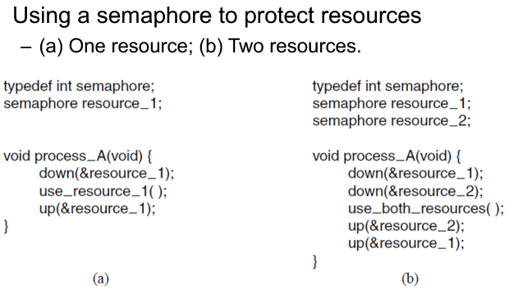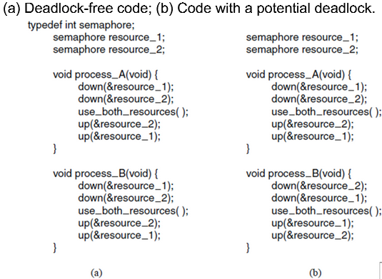

A set of processes is deadlocked if:

– Each process in the set is waiting for an event

– That event can be caused only by another process in the set

## Conditions for Resource Deadlocks

Four conditions that must all hold for a deadlock to exist:

1. Mutual exclusion

• Each resource is either currently assigned to exactly one process or is available

2. Hold and wait

• Processes currently holding resources that were granted earlier can request new resources

3. No preemption

• Resources previously granted cannot be forcibly taken away from a process. They must be explicitly released by the process holding them

4. Circular wait condition

• There must be a circular list of two or more processes, each of which is waiting for a resource held by the next member of the chain

## Deadlock Modelling

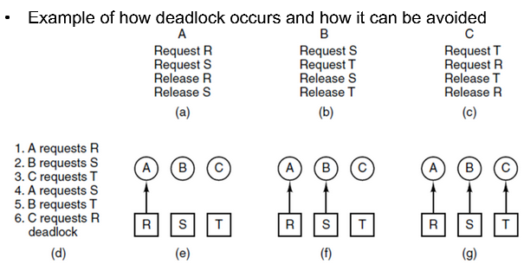  
  
  
  
  
  
  
  
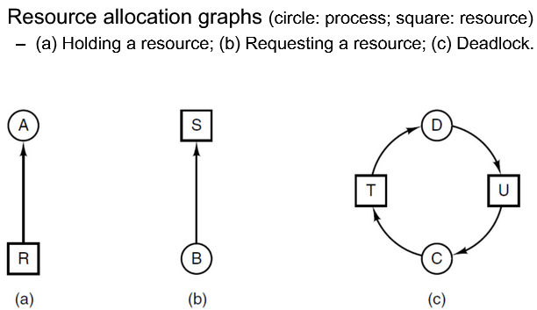

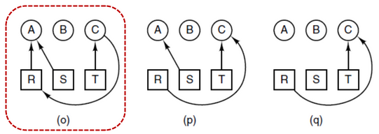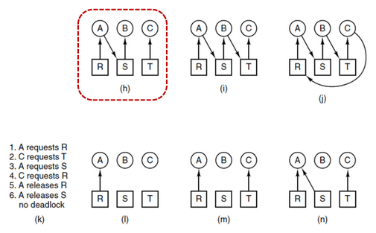  
  
  
  
  
  
  
  
  
  
  
  
  
  
  
  
  
  
  
  
  
  
  
  
  
  
  
  
  
  
  
  
  
  
  
Strategies that are used for dealing with deadlocks:

1. Ignore the problem, maybe it will go away…

2. Detection and recovery. Let deadlocks occur, detect them, and take action

3. Dynamic avoidance by careful resource allocation

4. Prevention, by structurally negating one of the four required conditions

## Deadlock Detection

Deadlock Detection with One Resource of Each Type

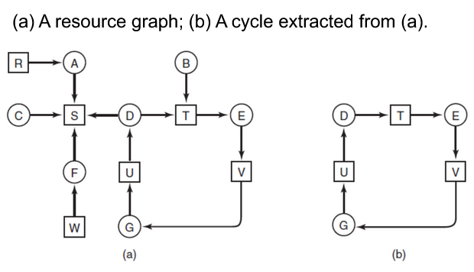Example of a system – is it deadlocked?

1. Process A holds R, wants S

2. Process B holds nothing, wants T

3. Process C holds nothing, wants S

4. Process D holds U, wants S and T

5. Process E holds T, wants V

6. Process F holds W, wants S

7. Process G holds V, wants U

Algorithm to Detect Deadlocks:

For each node N in the graph, perform following five steps with N as starting node:

1. Initialize L to empty list, and designate all arcs as unmarked

2. Add current node to end of L, check to see if node now appears in L two times. If so, graph contains a cycle (listed in L ) and algorithm terminates

3. From the given node, see if there are any unmarked outgoing arcs. If so, go to step 4; if not, go to step 5.

4. Pick unmarked outgoing arc at random, mark it. Follow to new current node and go to step 2.

5. If this is the initial node, the graph does not contain cycles, and the algorithm terminates. Otherwise, dead end. Remove it and go back to the previous node.

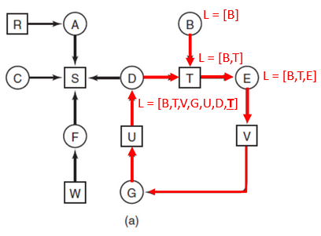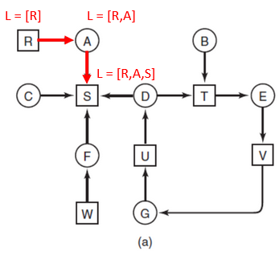

Deadlock Detection with Multiple Resources of Each Type

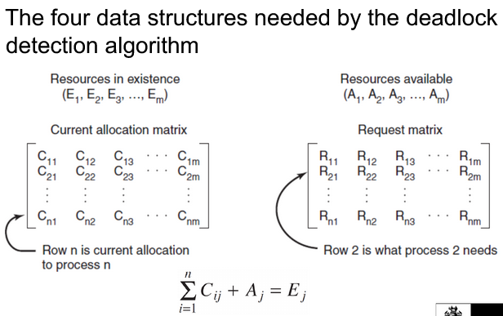

Deadlock detection algorithm:

1. Look for unmarked process, Pi, for which the i-th row of R is less than or equal to A

2. If such a process is found, add the i-th row of C to A, mark the process, go back to step 1

3. If no such process exists, algorithm terminates

If there are unmarked processes when the algorithm finishes these are deadlocked

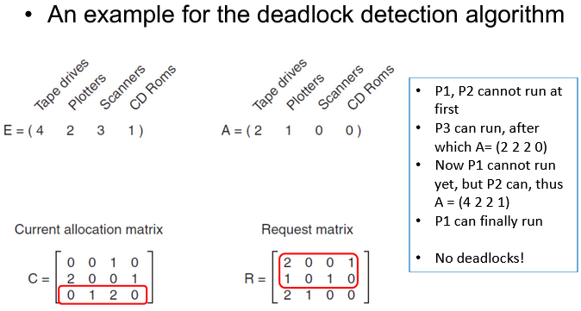

## Recovery from Deadlock

Possible methods of recovery (though none are “attractive”):

Preemption

• Temporarily take away the resource

• Highly dependent on the nature of the resource

Rollback

• Checkpoint regularly (save state)

• Rollback to a previous state when a deadlock is detected

Killing processes

• Break the deadlock by killing processes (all involved or one by one until others can continue)

## Avoiding Deadlocks

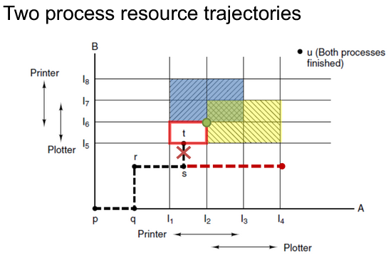

Deadlock avoidance uses the concept of safe/unsafe state, based on the model discussed for detection

A state is said to be safe if there is some scheduling order in which every process can run to completion even if all of them suddenly request their maximum number of resources immediately

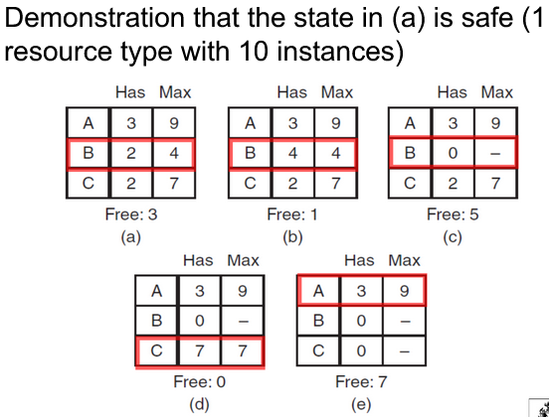

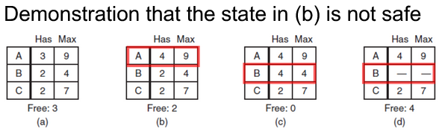  
  
  
  
  
  
  
  
  
  
  
  
  
  
  
  
  
  
  
  
  
the difference between safe and unsafe state is that from a safe state the system can guarantee that all processes will finish; from an unsafe state, there is no such guarantee

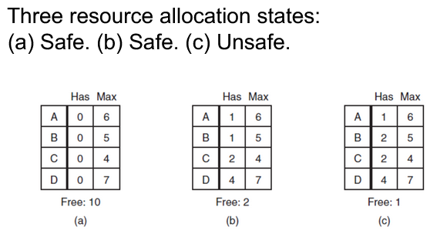Banker’s Algorithm

Single resource:

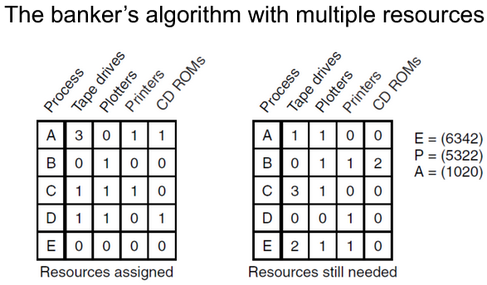  
  
  
  
  
  
  
  
  
  
Multiple resources:

E = resources in existence, P = resources currently allocated, A = resources available

1. Look for a row, R, whose unmet resource needs are all smaller than or equal to A. If no such row exists, system will eventually deadlock.

2. Assume the process of the chosen row requests all resources needed and finishes. Mark that process as terminated, add its resources to the A vector.

Repeat steps 1 and 2 until either all processes are marked terminated (the initial state is safe) or no process is left whose resource needs can be met (the initial state is unsafe)

## Deadlock Prevention

Deadlock avoidance can only be implemented if there is detailed information about future requests, which is not common

Deadlock prevention can be used in more realistic scenarios

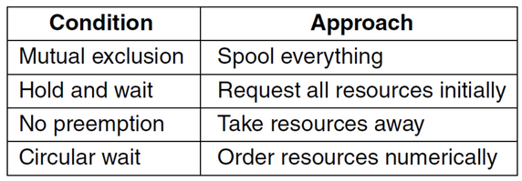

Assure that at least one of the conditions is never satisfied:

– Mutual exclusion

– Hold and wait

– No Preemption

– Circular wait

Attacking Mutual-Exclusion

If no resource were ever assigned exclusively to a single process, there would never be deadlocks

– Yet, this does not work in practice – how can two processes write on the printer at the same time?

However, avoiding assigning a resource unless absolutely necessary is a good idea

Attacking Hold-and-Wait

Preventing processes that hold resources from waiting for more resources, eliminates deadlocks

– Requires all processes to request all resources before starting execution

– Problem: many processes do not know how many resources they need at the start

Attacking No-Preemption

• For resources that are virtualized it is possible to use pre-emption

• Not all fit that category

– For example, records in databases or tables inside the

operating system must be locked to be used and therein lies

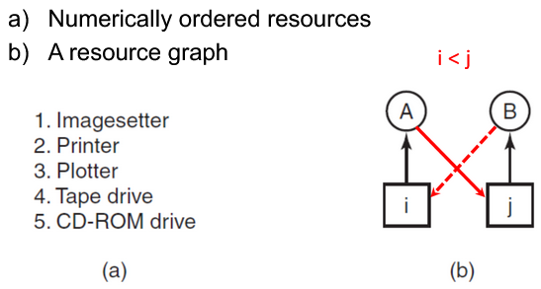 the potential for deadlock.

Attacking Circular Wait Condition

• Requests need to be made in numerical order

– With this rule, the resource allocation graph can never have

cycles.

## Communication Deadlocks

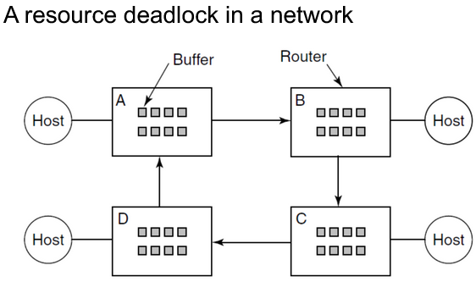

## Livelock

processes are not blocked but no progress is possible

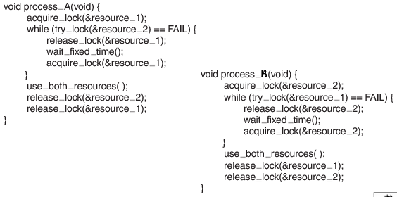

## Starvation

If many processes require the same resource, some might never have a chance to use it (starvation), depending on the resource allocation algorithm

• Algorithms like first-come, first-served do not cause starvation

# Virtualization

It is common for organizations to have multiple computers to separately address a number of services:

– Web server

– E-mail server

– Accounting tools

– …

Separation is, however, expensive

– Hardware

– Maintenance/support

A solution that has been used already for some time is virtualization

– A simulation of multiple machines on the same physical hardware

A VMM (Virtual Machine Monitor), also known as hypervisor, gives support to this

## Requirements for Virtualization

Hypervisors should score well in three dimensions:

1. Safety: hypervisor should have full control of virtualized resources.

2. Fidelity: behavior of a program on a virtual machine should be identical to same program running on bare hardware

3. Efficiency: much of code in virtual machine should run without intervention by hypervisor

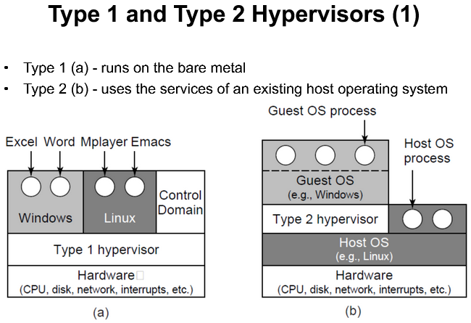

## Techniques for Efficient Virtualization

When the OS in a VM executes a kernel-only instruction, it traps to the hypervisor if virtualization technology (VT) is present in the CPU

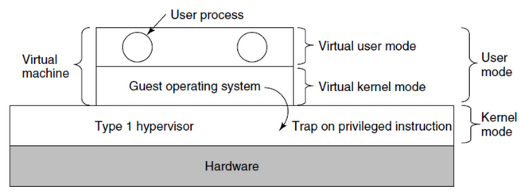

## Virtualizing the Unvirtualizable

When no VT exists, the binary translator rewrites the guest operating system running in ring 1, while the hypervisor runs in ring 0

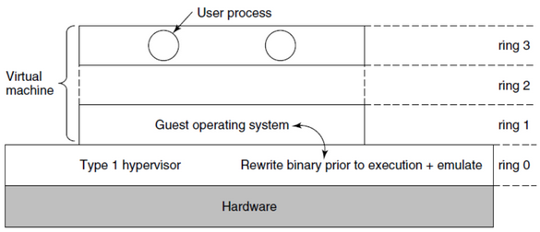

## Cost of Virtualization

To VT, or not to VT?

• Execution directly in the hardware many times outperforms a software layer

• However, the VT trap-and-emulate generates many traps, which are quite expensive

– Ruin the CPU cache, TLBs and branch prediction tables

• Translating the sensitive instructions by calls to hypervisor procedures does not incur in context-

switching overheads

Depending on workload, software sometimes beats hardware

Some hypervisors do binary translation even in the presence of VT for performance reasons

Still, with modern VT hardware, usually the hardware beats the software

## Hypervisors Microkernels

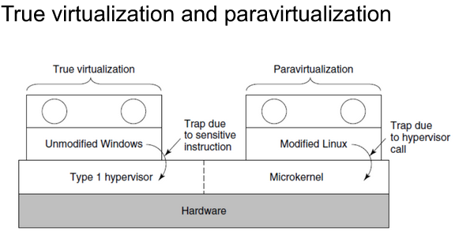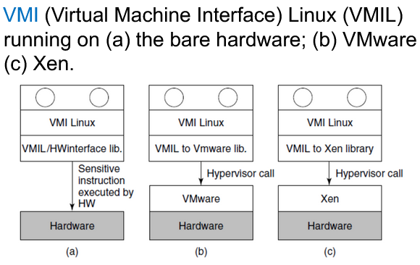

## Memory Virtualization

Virtual memory poses a problem to memory virtualization

– Virtual machines do not have access to each others’ virtual memory mapping

What can a hypervisor do if two virtual machines map some virtual pages to the same physical ones?

– A possibility is to give alternative physical addresses (if available) but would require changing the page tables.

– Normally the hypervisor creates a shadow page table that maps the virtual pages used by machines to the actual ones it gave them

## Hardware Support For Nested Page Tables

Extended/nested page tables are walked every time a guest physical address is accessed—including the accesses for each level of the guest’s page tables.

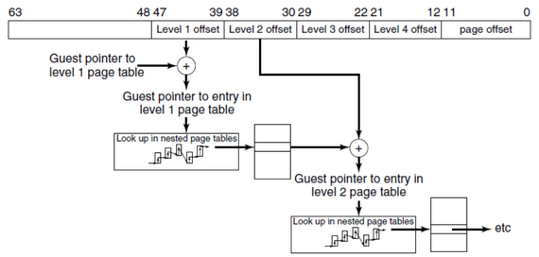

## I/O Virtualization

How to give access to I/O devices?

– Transparent: has issues, for example each guest OS will think they own the entire disk/partition

Besides the obvious solution of giving each guest OS a different disk partition, it is also possible for the hypervisor to create a file on the physical disk for each of the VM’s physical disks

How does networking work?

• There are several strategies, including having the hypervisor act as a network switch

## Virtual Appliances

• Now that virtualization is widespread, VMs can be used as a mechanism to provide ready-built software installations

• Customers from software providers can receive a VM with the purchased products without a need to install them and all dependencies

Shrink-wrapped VMs – virtual appliances

## Licensing Issues

If a commercial application is installed in both the host and guest VM OS, does it count as one or two licenses?

It depends on the license agreement, but it is unfortunately not always clear

## Containers

Containers encapsulate the environment on which to run an application (or more) but, unlike VMs, they do not include the OS

• This allows multiple runtime environments in the same OS installation

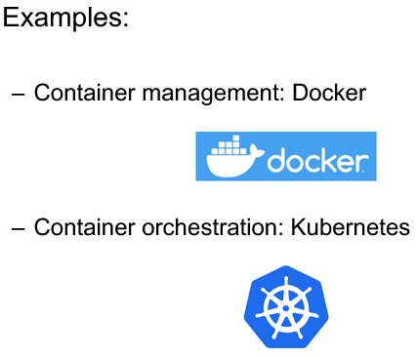• It is also possible to bundle all required libraries and software for a particular purpose in a container, and distribute software in this way